UNITED STATES
SECURITIES AND EXCHANGE COMMISSION
Washington, D.C. 20549
FORM 8-K
CURRENT REPORT
Pursuant to Section 13 or 15(d)
of the Securities Exchange Act of 1934
Date of Report (Date of earliest event reported): August 6, 2026

PRAXIS PRECISION MEDICINES, INC.
(Exact name of registrant as specified in its charter)

Delaware |  |  | 001-39620 |  |  | 47-5195942
(State or other jurisdiction  of incorporation) |  |  | (Commission  File Number) |  |  | (I.R.S. Employer  Identification No.)

Praxis Precision Medicines, Inc.
99 High Street, 30th Floor
Boston, Massachusetts 02110
(Address of principal executive offices, including zip code)
(617) 300-8460
(Registrant’s telephone number, including area code)
Not Applicable
(Former Name or Former Address, if Changed Since Last Report)

Check the appropriate box below if the Form 8-K filing is intended to simultaneously satisfy the filing obligation of the registrant under any of the following provisions:

☐ |  |  | Written communications pursuant to Rule 425 under the Securities Act (17 CFR 230.425)
☐ |  |  | Soliciting material pursuant to Rule 14a-12 under the Exchange Act (17 CFR 240.14a-12)
☐ |  |  | Pre-commencement communications pursuant to Rule 14d-2(b) under the Exchange Act (17 CFR 240.14d-2(b))
☐ |  |  | Pre-commencement communications pursuant to Rule 13e-4(c) under the Exchange Act (17 CFR 240.13e-4(c))
Securities registered pursuant to Section 12(b) of the Act:
Title of each class |  |  |  |  |  | Trade  Symbol(s) |  |  |  |  |  | Name of each exchange  on which registered
Common Stock, $0.0001 par value per share |  |  |  |  |  | PRAX |  |  |  |  |  | The Nasdaq Global Select Market
Indicate by check mark whether the registrant is an emerging growth company as defined in Rule 405 of the Securities Act of 1933 (§ 230.405 of this chapter) or Rule 12b-2 of the Securities Exchange Act of 1934 (§ 240.12b-2 of this chapter).
Emerging growth company ☐
If an emerging growth company, indicate by check mark if the registrant has elected not to use the extended transition period for complying with any new or revised financial accounting standards provided pursuant to Section 13(a) of the Exchange Act. ☐

Item 2.02. Results of Operations and Financial Condition.
On August 6, 2026, Praxis Precision Medicines, Inc. (the “Company”) announced its financial results for the quarter ended June 30, 2026. A copy of the press release containing these announcements is furnished as Exhibit 99.1 to this Current Report on Form 8-K (the “Current Report”).

Item 7.01. Regulation FD Disclosure.
On August 6, 2026, the Company updated its corporate presentation for use in meetings with investors, analysts and others. The presentation is available in the “Investors + Media” portion of the Company’s website at investors.praxismedicines.com and a copy is furnished as Exhibit 99.2 to this Current Report.
The information in this Current Report under Items 2.02 and 7.01, including Exhibit 99.1 and Exhibit 99.2 attached hereto, is intended to be furnished and shall not be deemed “filed” for purposes of Section 18 of the Securities Exchange Act of 1934, as amended (the “Exchange Act”), or otherwise subject to the liabilities of that section, nor shall it be deemed incorporated by reference in any filing under the Securities Act of 1933, as amended, or the Exchange Act, except as expressly set forth by specific reference in such filing.

Item 9.01. Financial Statements and Exhibits.
(d) Exhibits

Exhibit  No. |  |  |  |  |  | Description
99.1 |  |  |  |  |  | Press Release, dated August 6, 2026
99.2 |  |  |  |  |  | Praxis Precision Medicines, Inc. August 2026 Corporate Presentation
104 |  |  |  |  |  | Cover Page Interactive Data File (embedded within the inline XBRL document)

SIGNATURE
Pursuant to the requirements of the Securities Exchange Act of 1934, the registrant has duly caused this report to be signed on its behalf by the undersigned hereunto duly authorized.

 |  |  | PRAXIS PRECISION MEDICINES, INC.
Date: August 6, 2026 |  |  | By: |  |  |  |  |  | /s/ Marcio Souza
 |  |  |  |  |  |  |  |  | Marcio Souza
 |  |  |  |  |  |  |  |  | Chief Executive Officer


Praxis Precision Medicines Provides Corporate Update and Reports Second Quarter 2026 Financial Results
Mid-cycle meeting completed for ulixacaltamide HCl; FDA identified no major safety or efficacy concerns to date and does not plan to request an advisory committee meeting; PDUFA date of January 29, 2027
Mid-cycle meeting completed for relutrigine; FDA identified no major safety or efficacy concerns to date and does not plan to request an advisory committee meeting; PDUFA date of December 27, 2026
FDA Bioresearch Monitoring (BIMO) inspections of Praxis for both ulixacaltamide and relutrigine completed with no Form FDA 483 observations
Commercial infrastructure build-out accelerating for ulixacaltamide HCl in Essential Tremor and relutrigine in SCN2A and SCN8A developmental and epileptic encephalopathies (DEEs) ahead of expected approvals
Praxis received its third Breakthrough Therapy Designation following the positive results from the EMBRAVE Part A trial of elsunersen for the treatment of seizures associated with SCN2A DEE caused by gain of function variants
Cash and investments of approximately $1.4 billion as of June 30, 2026 maintains runway into 2028
Conference call today, August 6, 2026, at 8:30am
BOSTON, August 6, 2026 — Praxis Precision Medicines, Inc. (NASDAQ: PRAX), a fully integrated, leading central nervous system (CNS) precision neuroscience biopharmaceutical company, today provided a corporate update and reported financial results for the second quarter of 2026.
“This quarter reflected meaningful progress toward becoming a multi-product commercial company, with both ulixacaltamide and relutrigine advancing closer to patients through ongoing constructive dialogue with the FDA with positive mid-cycle meetings and BIMO sponsor inspections completed for both programs. We have also taken significant steps in launch preparations: our commercial leadership is in place, we are standing up our state-of-the-art commercial systems, and the momentum is tangible with field force hiring well under way,” said Marcio Souza, president and chief executive officer. “Across the rest of our portfolio, the Breakthrough Therapy Designation for elsunersen, our third in twelve months, further validates our position as a leader in CNS disease, our Solidus™ ASO platform for treating devastating CNS disorders and the depth of our CNS therapeutic development engine. Lastly, we’re excited to be continuing the POWER2 study with renewed conviction, informed by what we learned in POWER1, as we work to transform care for patients with focal epilepsy with vormatrigine.”
Recent Highlights and Anticipated Milestones
Cerebrum™ for Small Molecules
Ulixacaltamide for Essential Tremor (ET): ET is one of the most common movement disorders, affecting approximately seven million patients in the U.S. Ulixacaltamide is the first and only investigational therapy to demonstrate positive results in a Phase 3 program in ET and was granted Breakthrough Therapy Designation by the FDA in December 2025.
•NDA review is progressing as expected, with a PDUFA date of January 29, 2027.
•The mid-cycle meeting was successfully completed and the FDA identified no major safety or efficacy concerns to date. The agency confirmed that no advisory committee meeting is planned.
•Launch preparation activities are accelerating, with commercial organization leaders hired and infrastructure, marketing and disease-education programs, medical information capabilities, physician targeting and an established distribution network with commercial inventory build in progress.
•A strategic collaboration was initiated in July 2026 with Remagine Labs to develop a transdermal patch of ulixacaltamide for ET. The transdermal formulation is designed to broaden ulixacaltamide’s addressable patient population, strengthen its competitive positioning, and support the long-term growth, durability, and value of the ulixacaltamide franchise.

Relutrigine for DEEs: Relutrigine is a sodium channel modulator designed to precisely target the hyperexcitable state of sodium-channels, with therapeutic potential across developmental epilepsies. Relutrigine has been granted Breakthrough Therapy Designation and Orphan Drug Designation by the FDA. If approved, relutrigine will be the first therapy for SCN2A and SCN8A DEEs and will be eligible for a Pediatric Review Voucher.
•Following the submission of additional sensitivity analyses of existing clinical data, which the FDA deemed collectively to be a major amendment, the FDA extended the review period for relutrigine’s NDA for the treatment of SCN2A and SCN8A DEEs and set a new PDUFA target action date of December 27, 2026.
•The mid-cycle meeting was successfully completed and the FDA has identified no major safety or efficacy concerns to date. The agency confirmed that no advisory committee meeting is planned.
•Preparations for the commercial launch of relutrigine are gaining momentum, with commercial and medical teams hired, building sufficient inventory, establishing a comprehensive patient support program and engaging with payers to ensure timely market access upon potential approval.
•Enrollment in the EMERALD study in broad DEEs exceeded the planned target with approximately 200 patients enrolled, spanning over 50 distinct genetically defined pathological etiologies in the trial population.
•Topline results are anticipated in the fourth quarter of 2026 and assuming successful initial NDA approval of relutrigine, the EMERALD study, if positive, would serve as the basis for a supplemental NDA submission in 2027.
NDA-related activities and updates for Ulixacaltamide HCl and Relutrigine
•Praxis operations were subject to inspections by the FDA in accordance with the BIMO program related to its NDAs for ulixacaltamide HCl for Essential Tremor and relutrigine for SCN2A and SCN8A DEEs. The scope of the inspections was comprehensive, spanning overall quality and clinical operations, data integrity, including statistical and interim analyses, and safety, amongst other standard areas in the BIMO program. The inspection was completed successfully, and no form 483 was issued.
•Acknowledging the late-stage discussions with the FDA in relation to both applications, Praxis does not intend to communicate regulatory updates going forward until the expected PDUFA dates.
Vormatrigine for Focal Onset Seizures (FOS) and Generalized Epilepsy: An estimated 3.5 million people in the U.S. suffer from common epilepsies. Sodium channel therapy is the cornerstone of treatment for patients with epilepsy, yet currently approved drugs have significant safety and efficacy limitations. Vormatrigine is the most potent sodium-channel modulator ever developed for epilepsy and is designed to precisely target the hyperexcitable state of sodium-channels in adult common epilepsies.
•In June, Praxis announced topline results from the POWER1 Phase 2/3 study in highly refractory patients with FOS.
•The study did not meet its primary endpoint of reduction in monthly focal seizure frequency from baseline at Week 12.
•The study met the secondary endpoint, with a significant number of patients achieving ≥50% reduction in seizure frequency.
•Praxis is finalizing the plans to restart the POWER2 study and initiate the POWER3 study in the fourth quarter of 2026 based on the learnings from POWER1
Solidus™ for Antisense Oligonucleotide (ASO)
•Elsunersen for early-seizure-onset SCN2A DEE: Early-onset SCN2A-DEE is a rare, genetic epilepsy characterized by early-onset seizures and severe impact on development.
•The FDA granted Breakthrough Therapy Designation to elsunersen based on positive results from the EMBRAVE Part A trial. Elsunersen now holds Breakthrough Therapy, Orphan Drug and Rare Pediatric Disease Designations from the FDA, and Orphan Drug and PRIME designations from the EMA.
•If approved, elsunersen will be eligible for a Pediatric Review Voucher.
•Enrollment in the EMBRAVE3 registrational trial is progressing, with topline results expected in 2027.
•Praxis remains on track to nominate development candidates for several early-stage ASO therapeutic initiatives in 2026.
Second Quarter 2026 Financial Results:

As of June 30, 2026, Praxis had $1.4 billion in cash, cash equivalents and marketable securities, compared to $926.1 million in cash, cash equivalents and marketable securities as of December 31, 2025. This increase of $447.8 million was primarily attributable to net proceeds from Praxis’ January 2026 follow-on public offering and interest income on marketable securities, partially offset by cash used in operations. The Company’s cash, cash equivalents and marketable securities as of June 30, 2026 are expected to fund operations into 2028.
Research and development expenses were $69.4 million for the second quarter of 2026, compared to $63.0 million for the second quarter of 2025. The increase in research and development expenses of $6.4 million was primarily attributable to $6.7 million in increased expenses related to Solidus™, $4.4 million in increased personnel-related costs and $1.8 million in increased indirect costs, partially offset by $6.5 million in decreased expenses related to Cerebrum™.
General and administrative expenses were $27.5 million for the second quarter of 2026, compared to $13.1 million for the second quarter of 2025. The increase in general and administrative expenses of $14.4 million was primarily attributable to $7.2 million in increased professional expenses and $6.3 million in increased personnel-related costs.
Praxis incurred a net loss of $83.7 million for the second quarter of 2026, including $11.3 million of stock-based compensation expense, compared to $71.1 million for the second quarter of 2025, including $7.8 million of stock-based compensation expense.
As of June 30, 2026, Praxis had 27.9 million shares of common stock outstanding.
Conference Call
Praxis will discuss second quarter 2026 financial results and business highlights on a conference call taking place today, August 6 at 8:30 am ET, which can be accessed by dialing (800) 715-9871 with passcode 7796789 or by registering for the webcast, here. The live audio webcast will also be available through the Events & Presentations page of the Investors + Media section of the Company’s website.
About Ulixacaltamide
Ulixacaltamide is a differentiated and highly selective small molecule inhibitor of T-type calcium channels designed to block abnormal neuronal burst firing in the Cerebello-Thalamo-Cortical (CTC) circuit correlated with tremor activity. Ulixacaltamide has received Breakthrough Therapy Designation from the FDA and is the most advanced program of Praxis’ Cerebrum™ small molecules.
About Relutrigine
Relutrigine is a first-in-class small molecule in development for the treatment of developmental and epileptic encephalopathies (DEEs). Relutrigine is a functional state-selective sodium channel (NaV) modulator that preferentially modulates NaV channels under the conditions associated with pathological neuronal hyperexcitability, including sustained depolarization, repetitive firing and increased persistent current where present. By preferentially targeting pathological NaV channel activity while sparing normal NaV function, relutrigine is designed to provide broad efficacy across DEEs with differing etiologies and improved tolerability relative to traditional sodium channel blockers. In vivo studies of relutrigine have demonstrated dose-dependent inhibition of seizures up to complete control of seizure activity in SCN2A, SCN8A and other DEE mouse models. Relutrigine has received Orphan Drug Designation (ODD) and Rare Pediatric Disease Designation from the FDA for the treatment of SCN2A-DEE, SCN8A-DEE and Dravet syndrome; as well as Breakthrough Therapy Designation (BTD), and ODD from the European Medicines Agency for the treatment of SCN2A-DEE and SCN8A-DEE. To learn more about the EMERALD study, please visit Emerald | Resilience Studies.
About Vormatrigine
Vormatrigine is a next-generation small-molecule sodium channel modulator currently being developed as a once-daily oral treatment for adults with focal-onset seizures and generalized epilepsy. Vormatrigine is designed to preferentially inhibit the pathologically increased neuronal firing that underlies seizures while relatively preserving normal physiological activity. Preclinical data demonstrate differentiation from current standards of care and support its potential to be a best-in-class treatment for focal epilepsy. In vitro, vormatrigine has demonstrated preferential modulation of NaV channels under the sustained depolarization and repetitive-firing conditions associated with seizure activity.

In vivo studies of vormatrigine have demonstrated unprecedented potency in the maximal electroshock seizure (MES) model, a highly predictive translational model for efficacy in focal epilepsy. Data from patients in the RADIANT study demonstrated a robust seizure reduction and generally well tolerated profile. To learn more about the POWER2 study, please visit POWER studies.
About Elsunersen
Elsunersen is an antisense oligonucleotide (ASO) designed to selectively decrease SCN2A gene expression, directly targeting the underlying cause of early-seizure-onset SCN2A-DEE to treat seizures and other symptoms in patients with gain-of-function SCN2A mutations. In vitro studies of elsunersen have demonstrated reduction in both SCN2A gene expression and protein levels. In vivo, elsunersen has demonstrated significant, dose-dependent reduction in seizures, improvement in behavioral and locomotor activity and increased survival in SCN2A mouse models. Elsunersen has received BTD, ODD and RPDD from the FDA, and ODD and PRIME designations from the European Medicines Agency for the treatment of SCN2A-DEE. The elsunersen program is ongoing under a collaboration with Ionis Pharmaceuticals, Inc., and RogCon, Inc. To learn more about the EMBRAVE3 study, please visit Embrave | Resilience Studies.
About Praxis
Praxis Precision Medicines is a fully integrated, leading central nervous system (CNS) precision neuroscience biopharmaceutical company, translating insights from genetic epilepsies into the development of therapies for CNS disorders characterized by neuronal excitation-inhibition imbalance. Praxis is applying genetic insights to the discovery and development of therapies for rare and more prevalent neurological disorders for small molecules through Cerebrum™, and for antisense oligonucleotides (ASOs) through Solidus™, using our understanding of shared biological targets and circuits in the brain. Praxis has established a diversified, multimodal CNS portfolio including multiple programs across movement disorders and epilepsy, with four late-stage product candidates. For more information, please visit www.praxismedicines.com and follow us on Facebook, LinkedIn and X/Twitter.
Forward-Looking Statements
This press release contains forward-looking statements within the meaning of The Private Securities Litigation Reform Act of 1995 and other federal securities laws, including express or implied statements regarding Praxis’ future expectations, plans and prospects, including, without limitation, statements regarding the potential market opportunity and commercial potential of Praxis’ product candidates, the anticipated timing of regulatory submissions and interactions, the anticipated timing of clinical trials, the development of Praxis’ product candidates and plans to initiate new clinical programs, and our projected cash runway, as well as other statements containing the words “anticipate,” “believe,” “continue,” “could,” “endeavor,” “estimate,” “expect,” “anticipate,” “intend,” “may,” “might,” “plan,” “potential,” “predict,” “project,” “seek,” “should,” “target,” “will” or “would” and similar expressions that constitute forward-looking statements under the Private Securities Litigation Reform Act of 1995.
The express or implied forward-looking statements included in this press release are only predictions and are subject to a number of risks, uncertainties and assumptions, including, without limitation: uncertainties inherent in clinical trials; the expected timing of clinical trials, data readouts and the results thereof, and submissions for regulatory approval or review by governmental authorities; regulatory approvals to conduct trials; and other risks concerning Praxis’ programs and operations as described in its Annual Report on Form 10-K for the year ended December 31, 2025 and other filings made with the Securities and Exchange Commission. Although Praxis’ forward-looking statements reflect the good faith judgment of its management, these statements are based only on information and factors currently known by Praxis. As a result, you are cautioned not to rely on these forward-looking statements. Any forward-looking statement made in this press release speaks only as of the date on which it is made. Praxis undertakes no obligation to publicly update or revise any forward-looking statement, whether as a result of new information, future developments or otherwise.

Investor Contact:
Praxis Precision Medicines
investors@praxismedicines.com
857-702-9452

Media Contact:
Dan Ferry
LifeSci Advisors
Daniel@lifesciadvisors.com
617-430-7576

PRAXIS PRECISION MEDICINES, INC.
CONDENSED CONSOLIDATED BALANCE SHEETS
(Amounts in thousands)
(Unaudited)
 |  |  | June 30, 2026 |  |  |  |  |  | December 31, 2025
Assets
Cash and cash equivalents |  |  | $ | 474,761 |  |  |  |  | $ | 357,329
Marketable securities |  |  | 899,080 |  |  |  |  |  | 568,759
Prepaid expenses and other current assets |  |  | 13,352 |  |  |  |  |  | 11,580
Property and equipment, net |  |  | 492 |  |  |  |  |  | 147
Operating lease right-of-use assets |  |  | 1,001 |  |  |  |  |  | 92
Internal-use software |  |  | 773 |  |  |  |  |  | —
Other assets |  |  | 643 |  |  |  |  |  | —
Total assets |  |  | $ | 1,390,102 |  |  |  |  | $ | 937,907
Liabilities and stockholders’ equity
Accounts payable |  |  | $ | 23,386 |  |  |  |  | $ | 24,628
Accrued expenses |  |  | 24,585 |  |  |  |  |  | 35,033
Operating lease liabilities |  |  | 1,087 |  |  |  |  |  | 110
Common stock |  |  | 15 |  |  |  |  |  | 15
Additional paid-in capital |  |  | 2,659,990 |  |  |  |  |  | 2,017,566
Accumulated deficit |  |  | (1,316,289) |  |  |  |  |  | (1,140,008)
Accumulated other comprehensive (loss) gain |  |  | (2,672) |  |  |  |  |  | 563
Total liabilities and stockholders' equity |  |  | $ | 1,390,102 |  |  |  |  | $ | 937,907

PRAXIS PRECISION MEDICINES, INC.
CONDENSED CONSOLIDATED STATEMENTS OF OPERATIONS
(Amounts in thousands, except share and per share amounts)
(Unaudited)
 |  |  | Three Months Ended  June 30, |  |  |  |  |  |  |  |  |  |  |  | Six Months Ended  June 30,
 |  |  | 2026 |  |  |  |  |  | 2025 |  |  |  |  |  | 2026 |  |  |  |  |  | 2025
Operating expenses:
Research and development |  |  | $ | 69,416 |  |  |  |  | $ | 63,006 |  |  |  |  | $ | 147,403 |  |  |  |  | $ | 123,812
General and administrative |  |  | 27,488 |  |  |  |  |  | 13,061 |  |  |  |  |  | 55,361 |  |  |  |  |  | 26,983
Total operating expenses |  |  | 96,904 |  |  |  |  |  | 76,067 |  |  |  |  |  | 202,764 |  |  |  |  |  | 150,795
Loss from operations |  |  | (96,904) |  |  |  |  |  | (76,067) |  |  |  |  |  | (202,764) |  |  |  |  |  | (150,795)
Other income:
Other income, net |  |  | 13,184 |  |  |  |  |  | 4,940 |  |  |  |  |  | 26,483 |  |  |  |  |  | 10,372
Total other income |  |  | 13,184 |  |  |  |  |  | 4,940 |  |  |  |  |  | 26,483 |  |  |  |  |  | 10,372
Net loss |  |  | $ | (83,720) |  |  |  |  | $ | (71,127) |  |  |  |  | $ | (176,281) |  |  |  |  | $ | (140,423)
Net loss per share attributable to common stockholders, basic and diluted |  |  | $ | (2.87) |  |  |  |  | $ | (3.31) |  |  |  |  | $ | (6.08) |  |  |  |  | $ | (6.60)
Weighted average common shares outstanding, basic and diluted |  |  | 29,131,375 |  |  |  |  |  | 21,474,827 |  |  |  |  |  | 29,008,351 |  |  |  |  |  | 21,266,490



Corporate Overview August 2026


2 This presentation may contain “forward-looking statements” within the meaning of the Private Securities Litigation Reform Act of 1995 relating to our business, operations, and financial conditions, including but not limited to express or implied statements regarding our current beliefs, expectations and assumptions regarding the future of our business and our future plans and strategies, including statements about the estimated market for our product candidates, if approved; our development plans and progress; our preclinical and clinical results and other future developments, including our cash runway; and regulatory submissions, approvals and timing thereof of any of our product candidates. Any forward-looking statements in this presentation are based on management’s current expectations and beliefs and are subject to a number of risks, uncertainties and important factors that may cause actual events or results to differ materially from those expressed or implied by any forward-looking statements contained in this presentation, including, without limitation, risks relating to: (i) the success and timing of our ongoing clinical trials, (ii) the success and timing of our product development activities and initiating clinical trials, (iii) the success and timing of our collaboration partners’ product development activities, (iv) the timing of and our ability to obtain and maintain regulatory approval of any of our product candidates, (v) our plans to research, discover and develop additional product candidates, (vi) our ability to enter into collaborations for the development of new product candidates, (vii) our ability to establish manufacturing capabilities, and our collaboration partners’ abilities to manufacture our product candidates and scale production, (viii) our ability to meet any specific milestones set forth herein, and (ix) the potential addressable market sizes for product candidates. New risks and uncertainties may emerge from time to time, and it is not possible to predict all risks and uncertainties. Except as required by applicable law, we do not plan to publicly update or revise any forward-looking statements contained herein, whether as a result of any new information, future events, changed circumstances or otherwise. Although we believe the expectations reflected in such forward-looking statements are reasonable, we can give no assurance that such expectations will prove to be correct. Accordingly, readers are cautioned not to place undue reliance on these forward-looking statements. For further information regarding the risks, uncertainties and other factors that may cause differences between our expectations and actual results, you should review the “Risk Factors” section of our Annual Report on Form 10-K for the year ended December 31, 2025 and other filings made with the Securities and Exchange Commission . Certain information contained in this presentation relates to or is based on studies, publications, surveys and other data obtained from third-party sources and our own internal estimates and research. While we believe these third-party sources to be reliable as of the date of this presentation, we have not independently verified, and make no representation as to the adequacy, fairness, accuracy or completeness of, any information obtained from third-party sources. In addition, all of the market data included in this presentation involves a number of assumptions and limitations, and there can be no guarantee as to the accuracy or reliability of such assumptions. Finally, while we believe our own internal research is reliable, such research has not been verified by any independent source. Forward Looking Statements

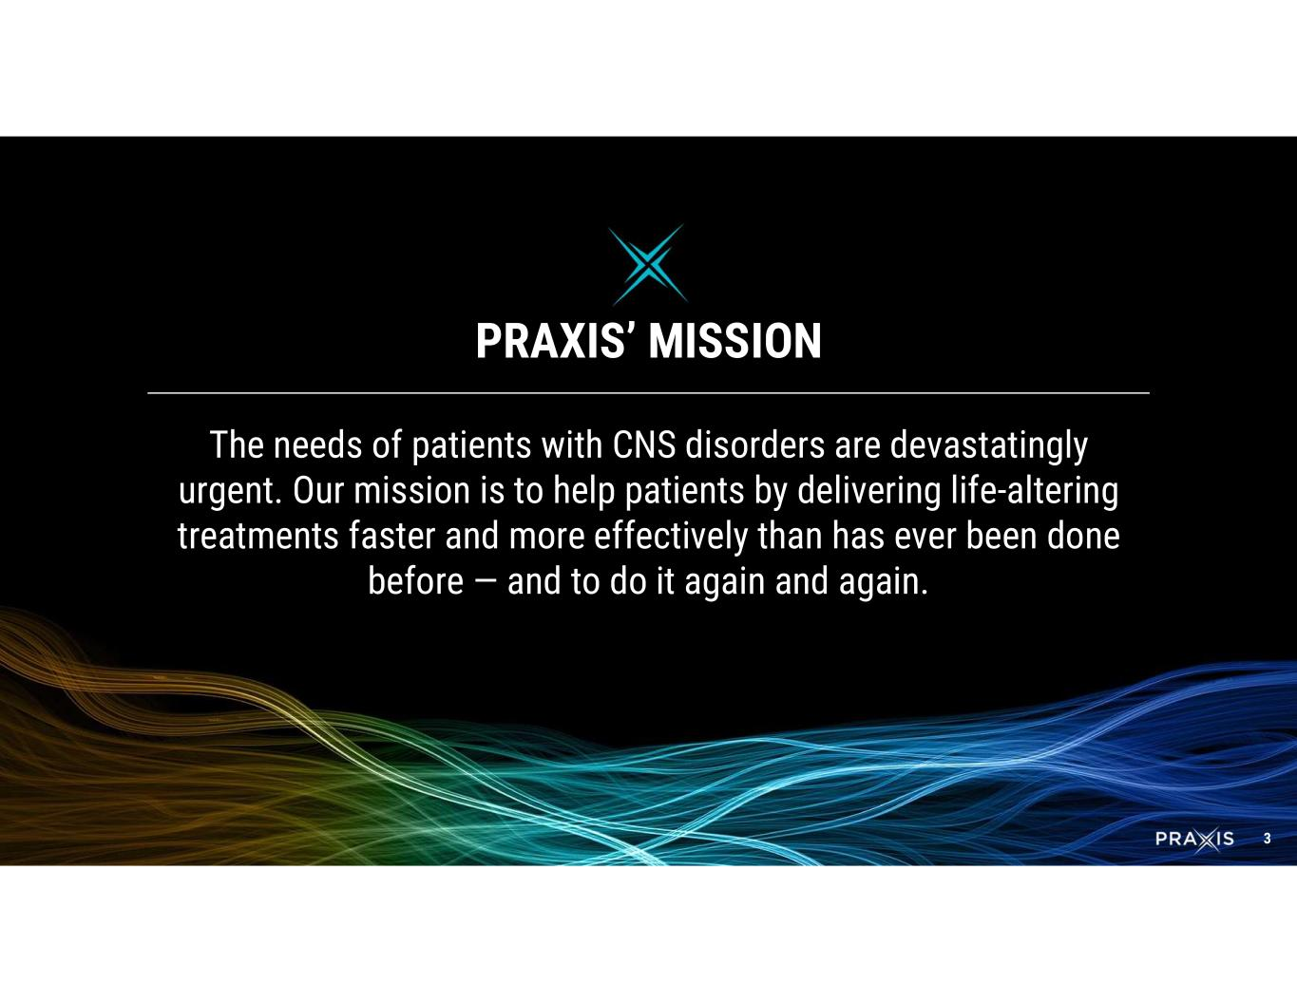
3 The needs of patients with CNS disorders are devastatingly urgent. Our mission is to help patients by delivering life-altering treatments faster and more effectively than has ever been done before — and to do it again and again. PRAXIS’ MISSION

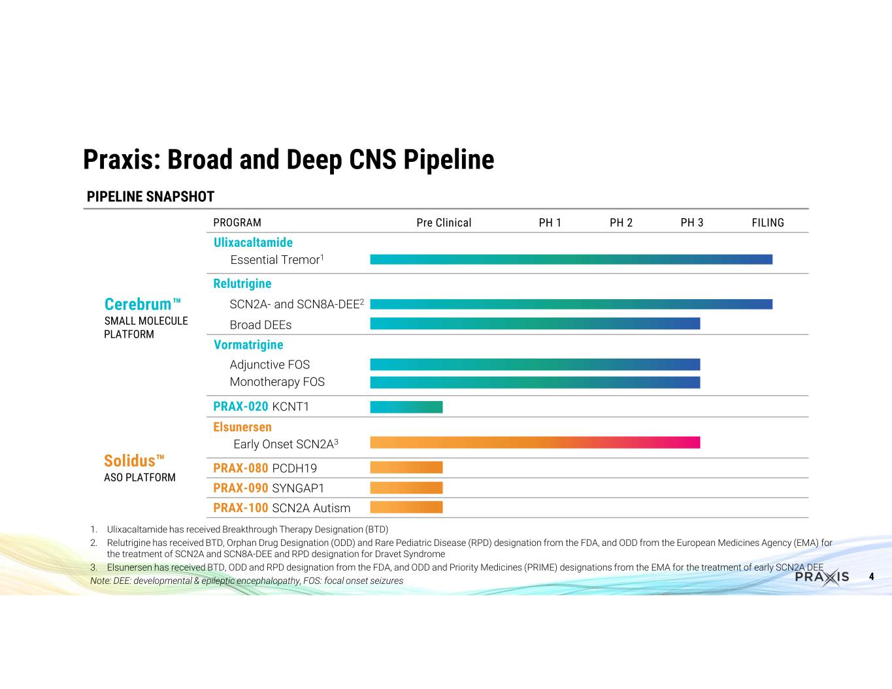
4 FILINGPH 3PH 2PH 1Pre ClinicalPROGRAM Ulixacaltamide Cerebrum SMALL MOLECULE PLATFORM Essential Tremor1 Relutrigine SCN2A- and SCN8A-DEE2 Broad DEEs Vormatrigine Adjunctive FOS Monotherapy FOS PRAX-020 KCNT1 Elsunersen Solidus ASO PLATFORM Early Onset SCN2A3 PRAX-080 PCDH19 PRAX-090 SYNGAP1 PRAX-100 SCN2A Autism 1. Ulixacaltamide has received Breakthrough Therapy Designation (BTD) 2. Relutrigine has received BTD, Orphan Drug Designation (ODD) and Rare Pediatric Disease (RPD) designation from the FDA, and ODD from the European Medicines Agency (EMA) for the treatment of SCN2A and SCN8A-DEE and RPD designation for Dravet Syndrome 3. Elsunersen has received BTD, ODD and RPD designation from the FDA, and ODD and Priority Medicines (PRIME) designations from the EMA for the treatment of early SCN2A DEE Note: DEE: developmental & epileptic encephalopathy, FOS: focal onset seizures PIPELINE SNAPSHOT Praxis: Broad and Deep CNS Pipeline

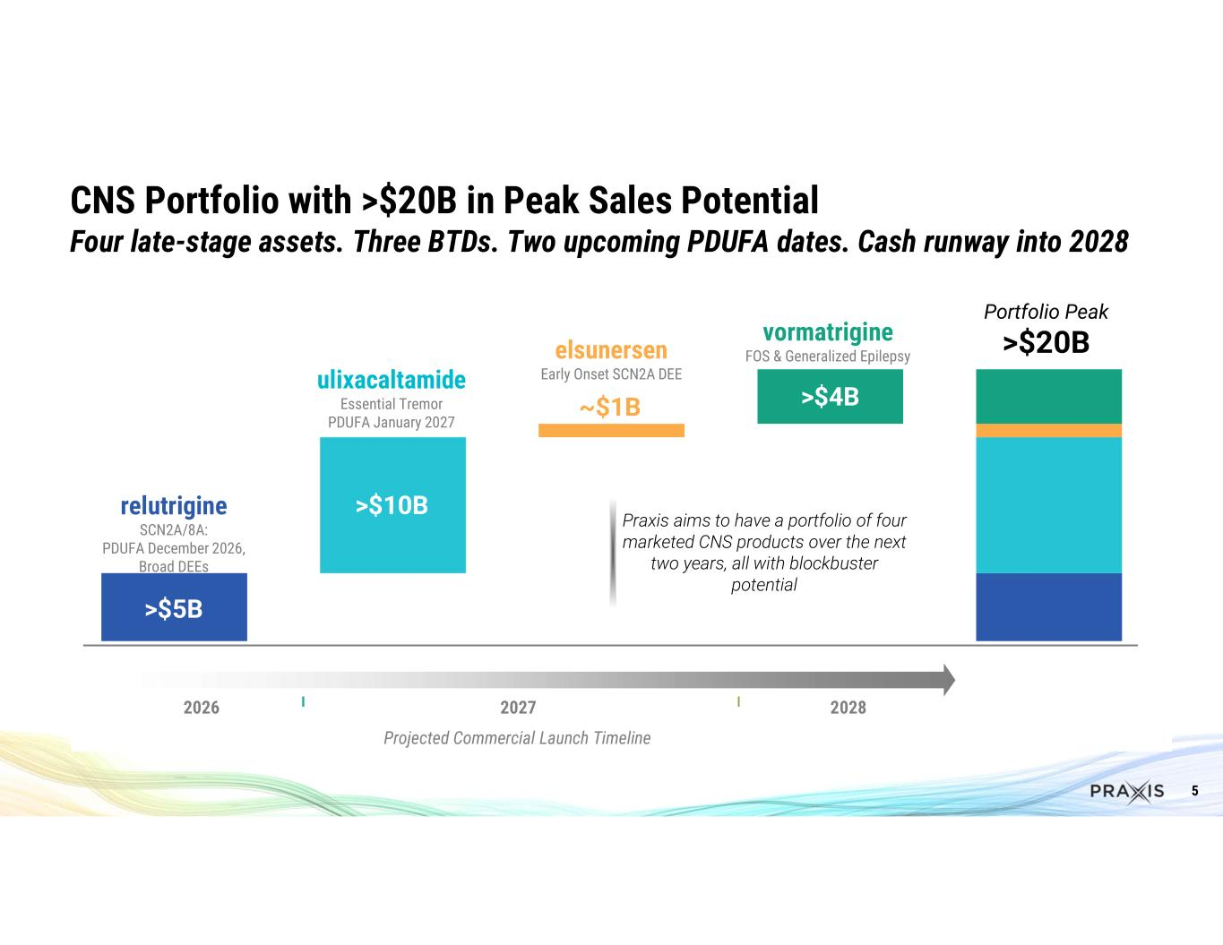
5 CNS Portfolio with >$20B in Peak Sales Potential Four late-stage assets. Three BTDs. Two upcoming PDUFA dates. Cash runway into 2028 ulixacaltamide Essential Tremor PDUFA January 2027 relutrigine SCN2A/8A: PDUFA December 2026, Broad DEEs vormatrigine FOS & Generalized Epilepsyelsunersen Early Onset SCN2A DEE >$10B >$5B ~$1B >$4B Portfolio Peak >$20B 2026 2027 2028 Projected Commercial Launch Timeline Praxis aims to have a portfolio of four marketed CNS products over the next two years, all with blockbuster potential

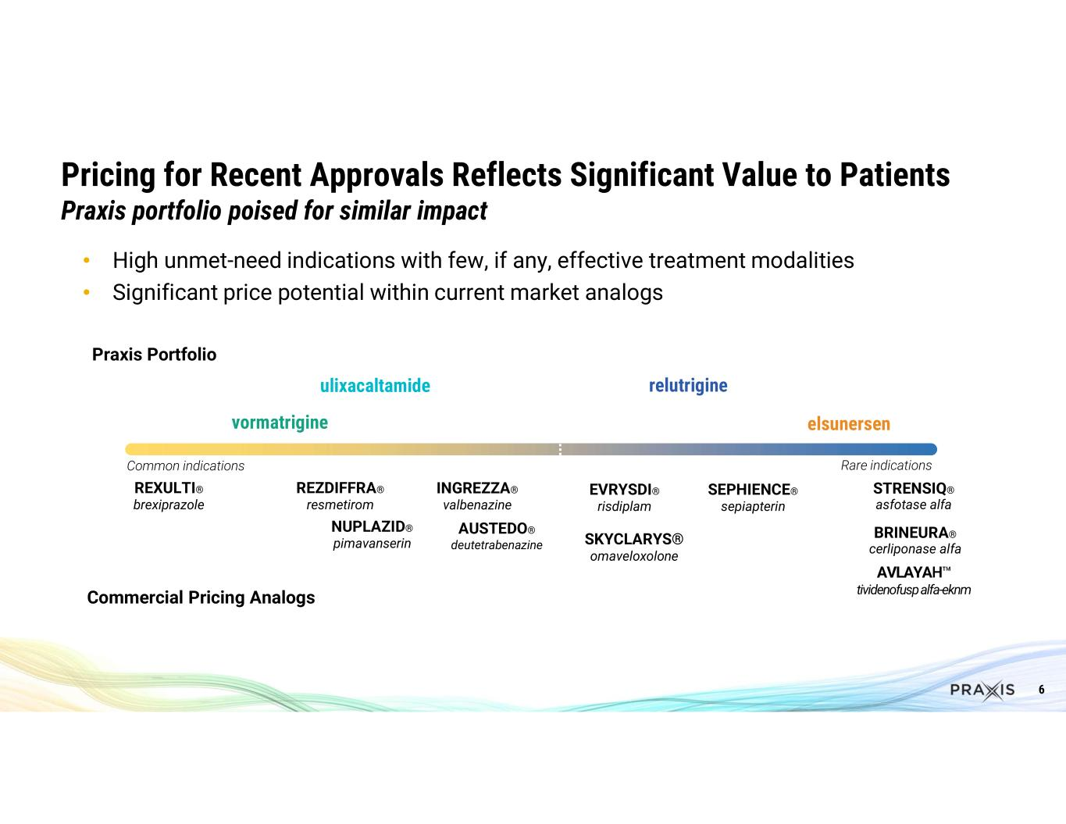
6 Pricing for Recent Approvals Reflects Significant Value to Patients Praxis portfolio poised for similar impact • High unmet-need indications with few, if any, effective treatment modalities • Significant price potential within current market analogs SKYCLARYS® omaveloxolone EVRYSDI® risdiplam SEPHIENCE® sepiapterin STRENSIQ® asfotase alfa BRINEURA® cerliponase alfa relutrigineulixacaltamide REZDIFFRA® resmetirom NUPLAZID® pimavanserin INGREZZA® valbenazine AUSTEDO® deutetrabenazine vormatrigine elsunersen Praxis Portfolio Commercial Pricing Analogs Common indications Rare indications REXULTI® brexiprazole AVLAYAH tividenofuspalfa-eknm

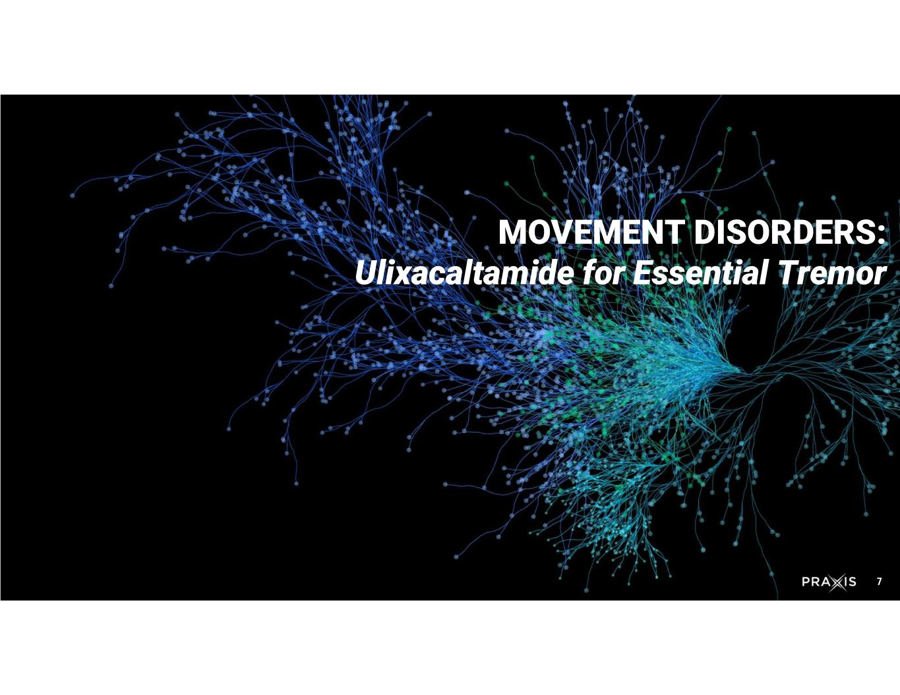
7 MOVEMENT DISORDERS: Ulixacaltamide for Essential Tremor

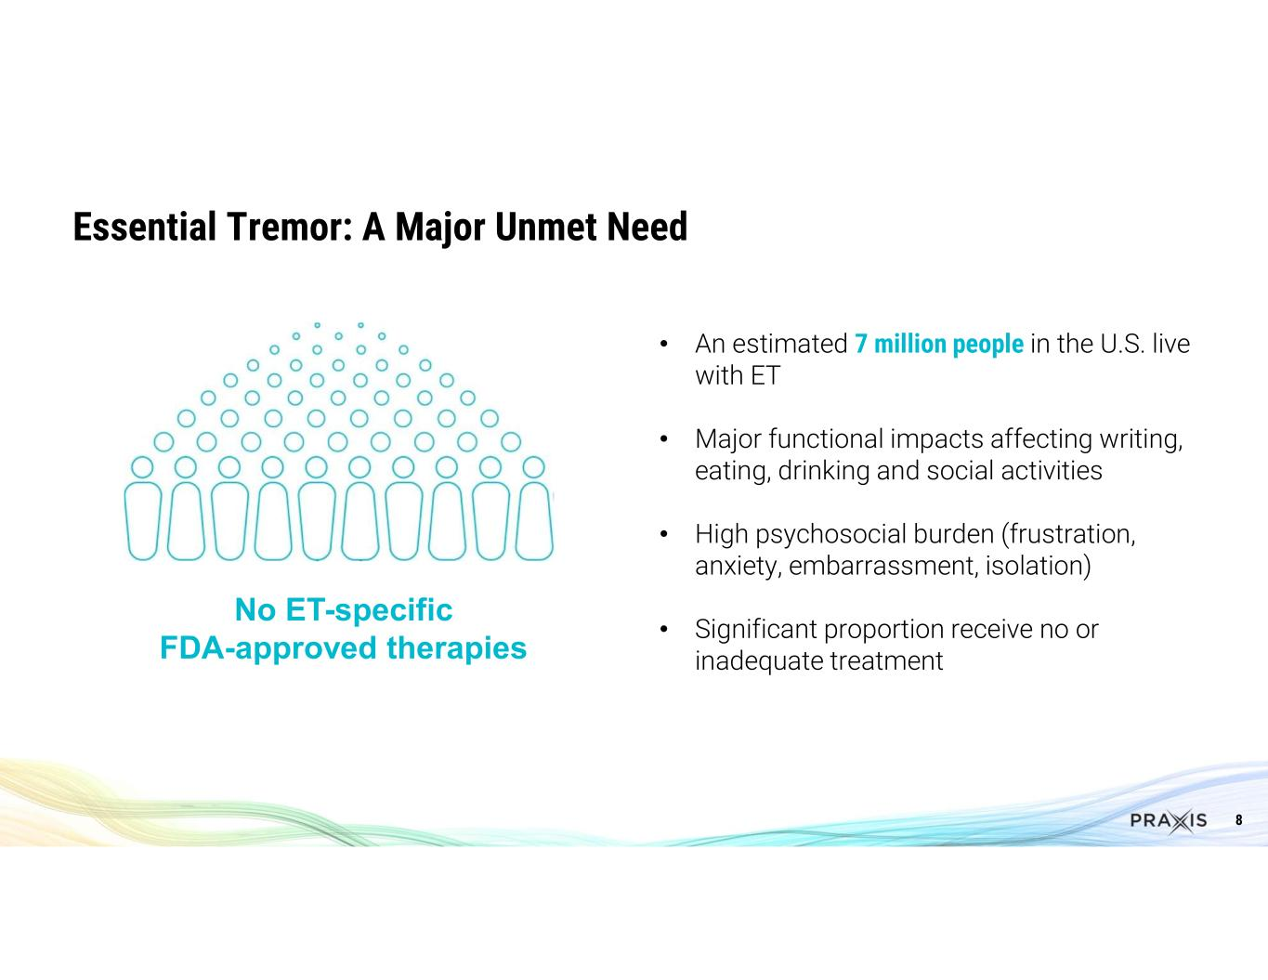
8 • An estimated 7 million people in the U.S. live with ET • Major functional impacts affecting writing, eating, drinking and social activities • High psychosocial burden (frustration, anxiety, embarrassment, isolation) • Significant proportion receive no or inadequate treatment Essential Tremor: A Major Unmet Need No ET-specific FDA-approved therapies

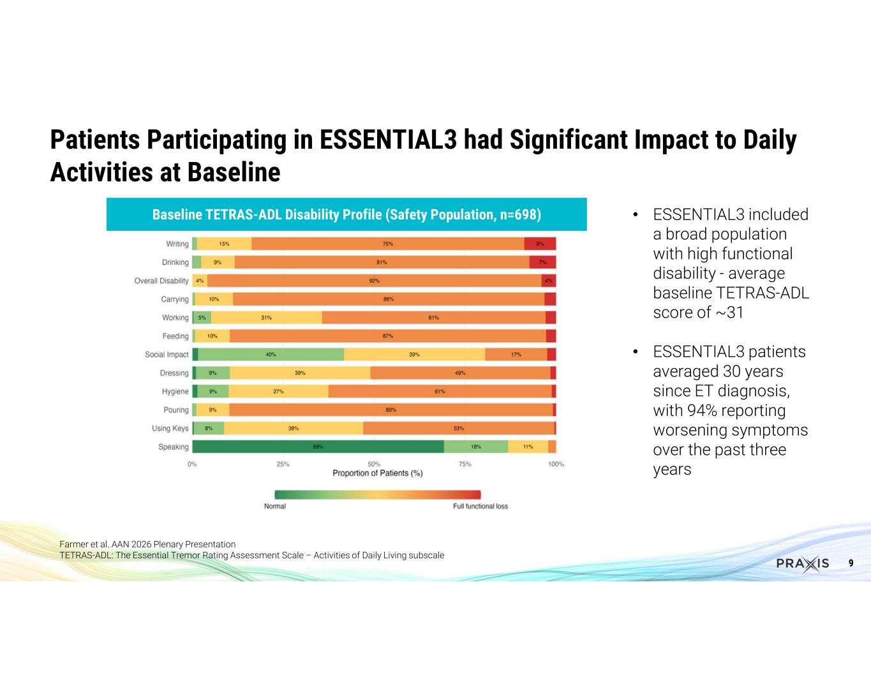
9 Patients Participating in ESSENTIAL3 had Significant Impact to Daily Activities at Baseline Farmer et al. AAN 2026 Plenary Presentation TETRAS-ADL: The Essential Tremor Rating Assessment Scale – Activities of Daily Living subscale Baseline TETRAS-ADL Disability Profile (Safety Population, n=698) • ESSENTIAL3 included a broad population with high functional disability - average baseline TETRAS-ADL score of ~31 • ESSENTIAL3 patients averaged 30 years since ET diagnosis, with 94% reporting worsening symptoms over the past three years

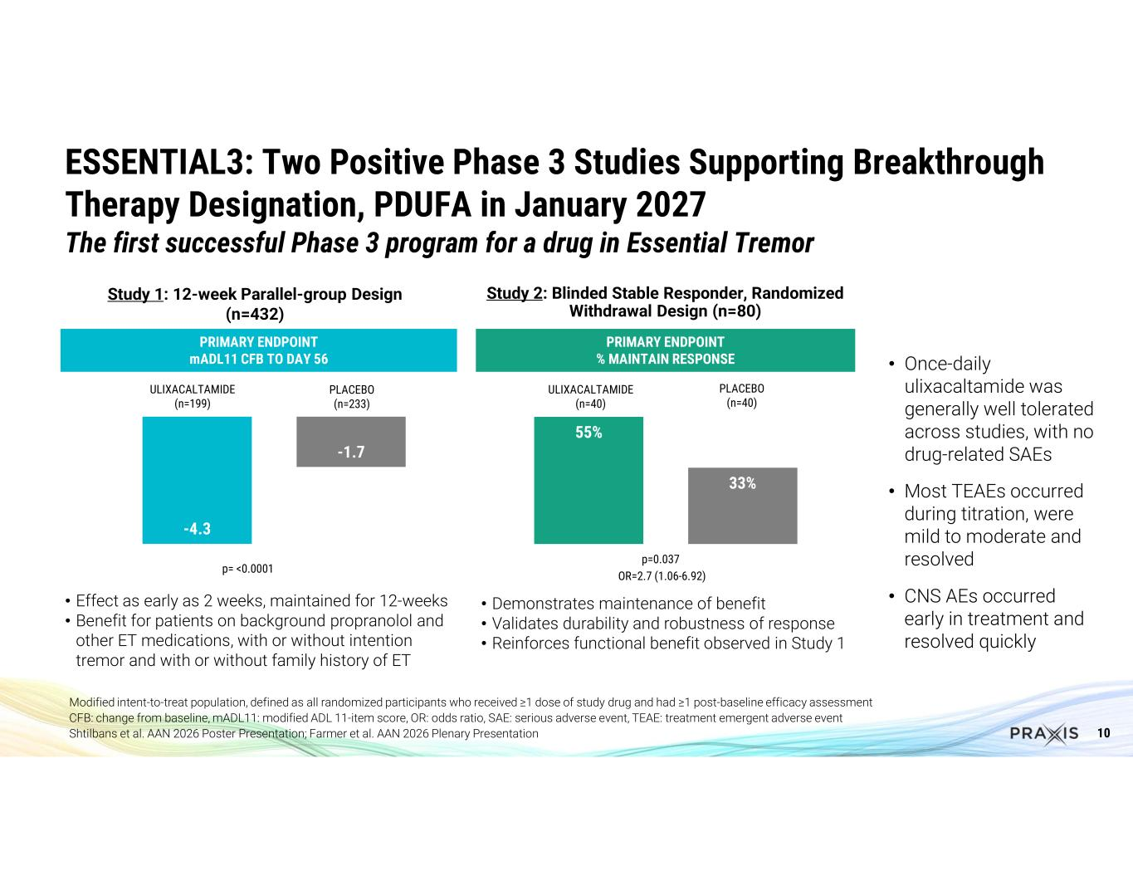
10 PRIMARY ENDPOINT % MAINTAIN RESPONSE ESSENTIAL3: Two Positive Phase 3 Studies Supporting Breakthrough Therapy Designation, PDUFA in January 2027 The first successful Phase 3 program for a drug in Essential Tremor -4.3 -1.7 p= <0.0001 ULIXACALTAMIDE (n=199) PLACEBO (n=233) 55% 33% p=0.037 ULIXACALTAMIDE (n=40) PLACEBO (n=40) OR=2.7 (1.06-6.92) • Effect as early as 2 weeks, maintained for 12-weeks • Benefit for patients on background propranolol and other ET medications, with or without intention tremor and with or without family history of ET • Demonstrates maintenance of benefit • Validates durability and robustness of response • Reinforces functional benefit observed in Study 1 Modified intent-to-treat population, defined as all randomized participants who received ≥1 dose of study drug and had ≥1 post-baseline efficacy assessment CFB: change from baseline, mADL11: modified ADL 11-item score, OR: odds ratio, SAE: serious adverse event, TEAE: treatment emergent adverse event Shtilbans et al. AAN 2026 Poster Presentation; Farmer et al. AAN 2026 Plenary Presentation PRIMARY ENDPOINT mADL11 CFB TO DAY 56 Study 1: 12-week Parallel-group Design (n=432) Study 2: Blinded Stable Responder, Randomized Withdrawal Design (n=80) • Once-daily ulixacaltamide was generally well tolerated across studies, with no drug-related SAEs • Most TEAEs occurred during titration, were mild to moderate and resolved • CNS AEs occurred early in treatment and resolved quickly

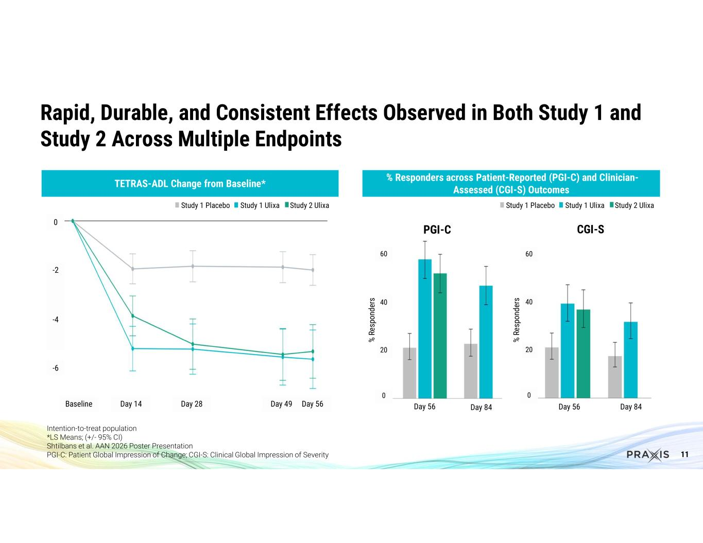
11 Rapid, Durable, and Consistent Effects Observed in Both Study 1 and Study 2 Across Multiple Endpoints Intention-to-treat population *LS Means; (+/- 95% CI) Shtilbans et al. AAN 2026 Poster Presentation PGI-C: Patient Global Impression of Change; CGI-S: Clinical Global Impression of Severity 0 -2 -4 -6 Baseline Day 14 Day 28 Day 49 Day 56 TETRAS-ADL Change from Baseline* Study 1 Placebo Study 1 Ulixa Study 2 Ulixa PGI-C Day 56 Day 84 60 40 20 0 CGI-S Day 56 Day 84 60 40 20 0 % R es po nd er s % Responders across Patient-Reported (PGI-C) and Clinician- Assessed (CGI-S) Outcomes Study 1 Placebo Study 1 Ulixa Study 2 Ulixa % R es po nd er s

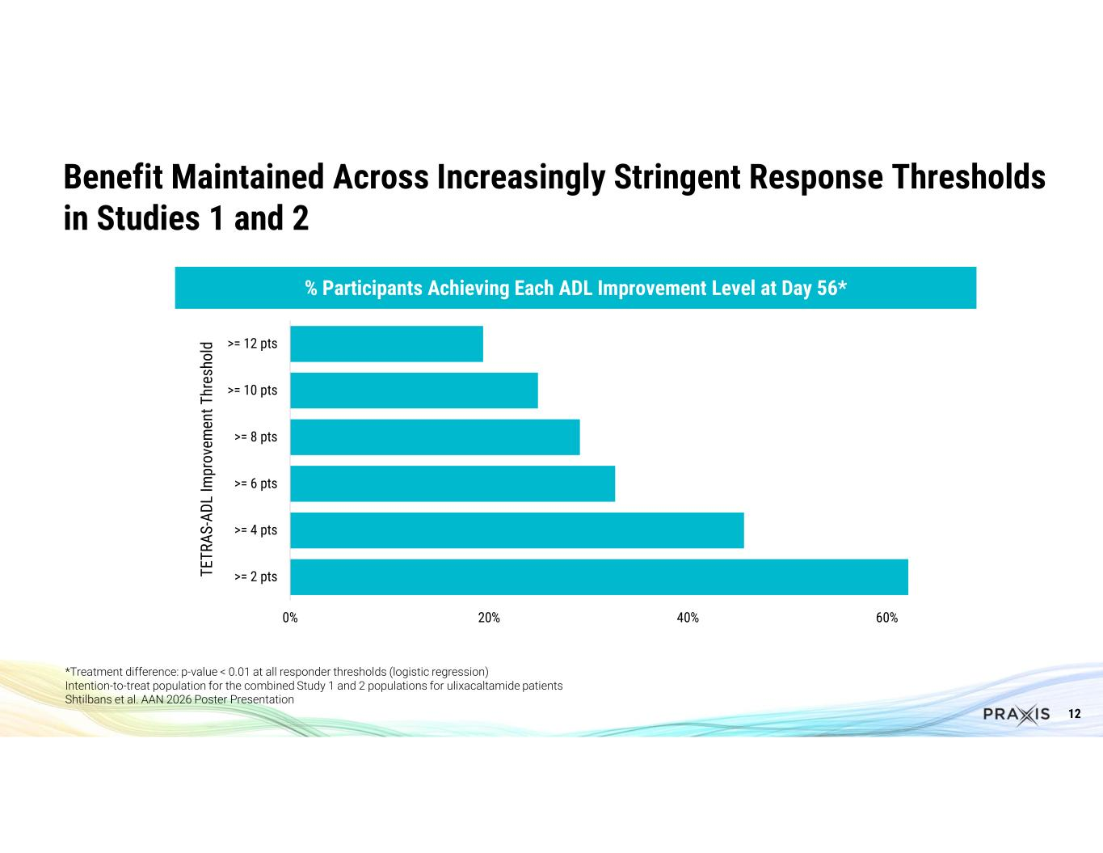
12 Benefit Maintained Across Increasingly Stringent Response Thresholds in Studies 1 and 2 *Treatment difference: p-value < 0.01 at all responder thresholds (logistic regression) Intention-to-treat population for the combined Study 1 and 2 populations for ulixacaltamide patients Shtilbans et al. AAN 2026 Poster Presentation 0% 20% 40% 60% >= 2 pts >= 4 pts >= 6 pts >= 8 pts >= 10 pts >= 12 pts TE TR AS -A DL Im pr ov em en t T hr es ho ld % Participants Achieving Each ADL Improvement Level at Day 56*

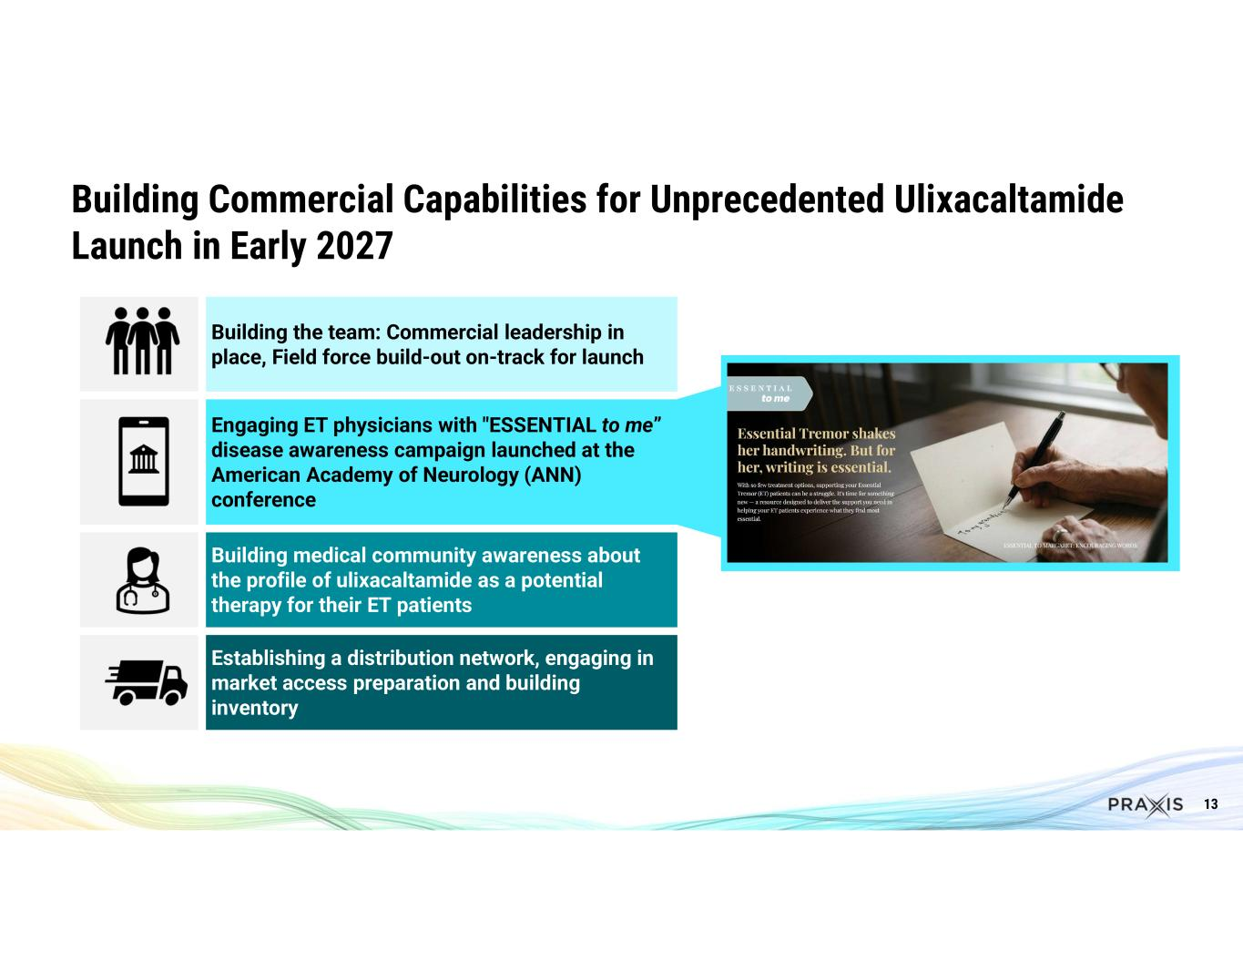
13 Building the team: Commercial leadership in place, Field force build-out on-track for launch Engaging ET physicians with "ESSENTIAL to me” disease awareness campaign launched at the American Academy of Neurology (ANN) conference Building medical community awareness about the profile of ulixacaltamide as a potential therapy for their ET patients Establishing a distribution network, engaging in market access preparation and building inventory Building Commercial Capabilities for Unprecedented Ulixacaltamide Launch in Early 2027

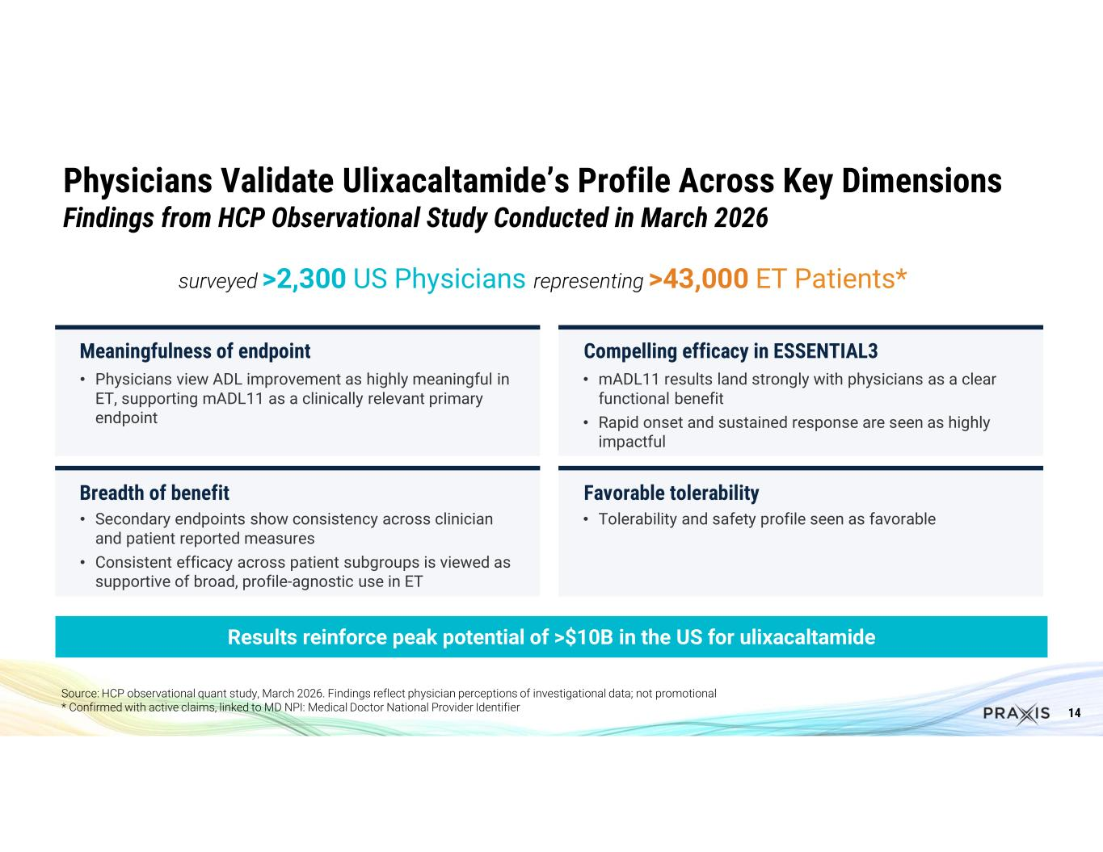
14 Physicians Validate Ulixacaltamide’s Profile Across Key Dimensions Findings from HCP Observational Study Conducted in March 2026 Results reinforce peak potential of >$10B in the US for ulixacaltamide surveyed >2,300 US Physicians representing >43,000 ET Patients* Meaningfulness of endpoint • Physicians view ADL improvement as highly meaningful in ET, supporting mADL11 as a clinically relevant primary endpoint Compelling efficacy in ESSENTIAL3 • mADL11 results land strongly with physicians as a clear functional benefit • Rapid onset and sustained response are seen as highly impactful Breadth of benefit • Secondary endpoints show consistency across clinician and patient reported measures • Consistent efficacy across patient subgroups is viewed as supportive of broad, profile-agnostic use in ET Favorable tolerability • Tolerability and safety profile seen as favorable Source: HCP observational quant study, March 2026. Findings reflect physician perceptions of investigational data; not promotional * Confirmed with active claims, linked to MD NPI: Medical Doctor National Provider Identifier

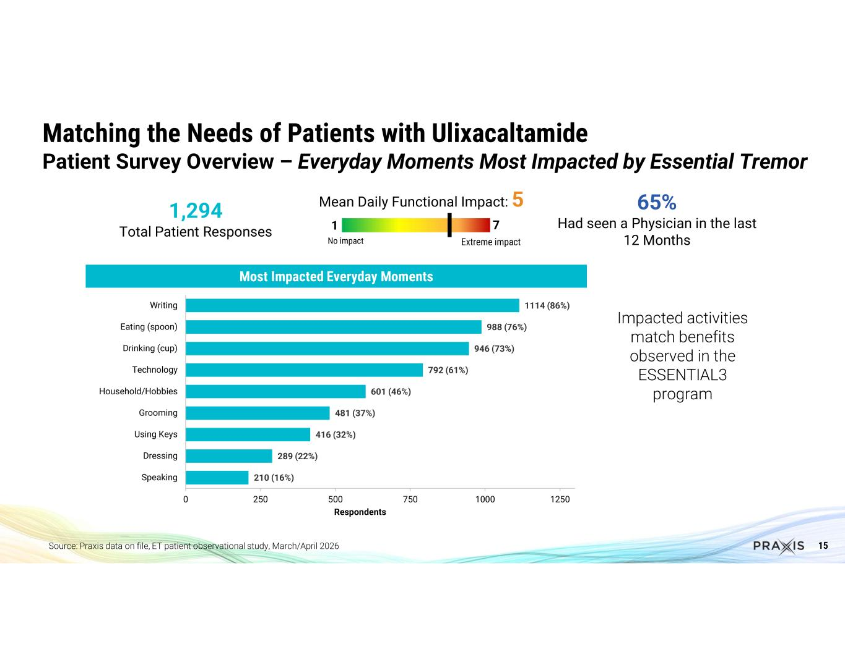
15 65% Had seen a Physician in the last 12 Months 1,294 Total Patient Responses Matching the Needs of Patients with Ulixacaltamide Patient Survey Overview – Everyday Moments Most Impacted by Essential Tremor 210 (16%) 289 (22%) 416 (32%) 481 (37%) 601 (46%) 792 (61%) 946 (73%) 988 (76%) 1114 (86%) 0 250 500 750 1000 1250 Speaking Dressing Using Keys Grooming Household/Hobbies Technology Drinking (cup) Eating (spoon) Writing Respondents Source: Praxis data on file, ET patient observational study, March/April 2026 Impacted activities match benefits observed in the ESSENTIAL3 program Most Impacted Everyday Moments Mean Daily Functional Impact: 5 No impact Extreme impact 1 7

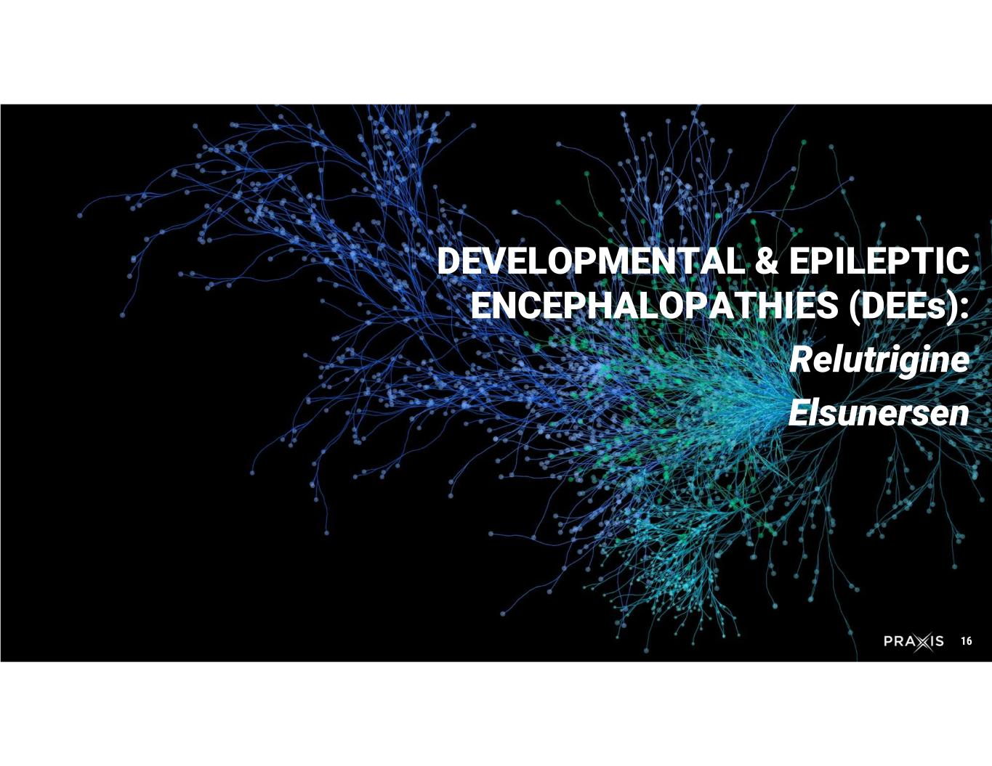
16 DEVELOPMENTAL & EPILEPTIC ENCEPHALOPATHIES (DEEs): Relutrigine Elsunersen

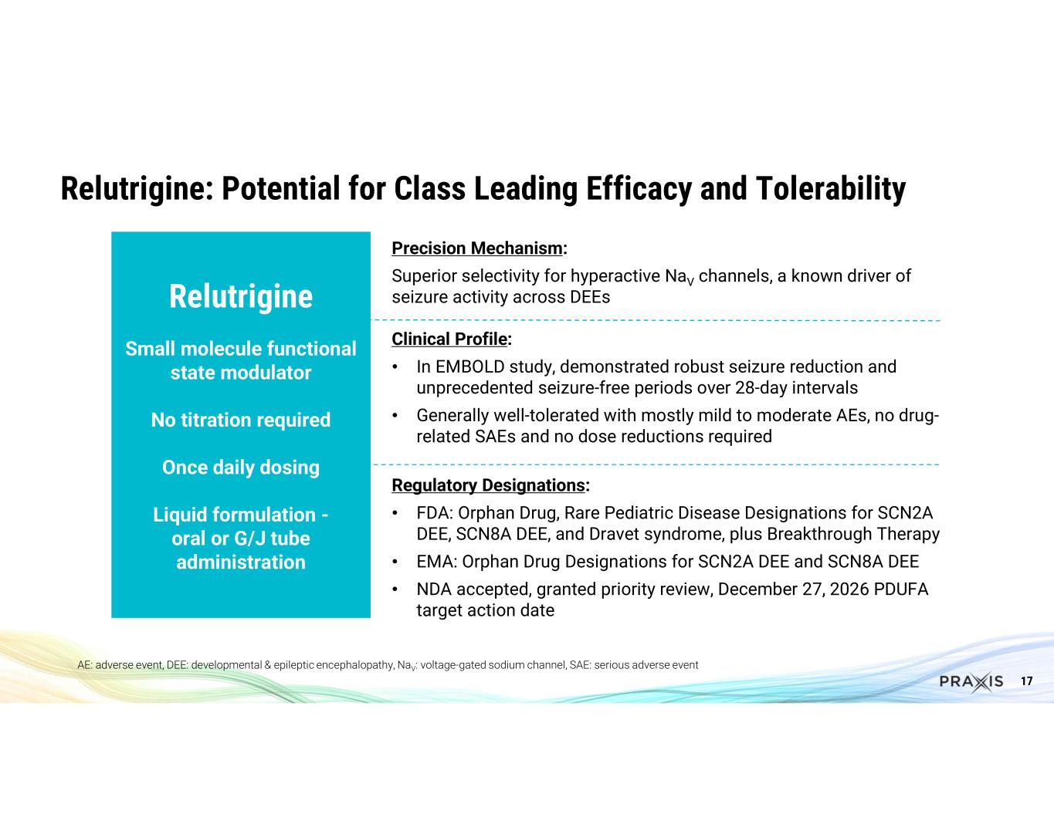
17 Relutrigine: Potential for Class Leading Efficacy and Tolerability AE: adverse event, DEE: developmental & epileptic encephalopathy, NaV: voltage-gated sodium channel, SAE: serious adverse event Relutrigine Small molecule functional state modulator No titration required Once daily dosing Liquid formulation - oral or G/J tube administration Precision Mechanism: Superior selectivity for hyperactive NaV channels, a known driver of seizure activity across DEEs Clinical Profile: • In EMBOLD study, demonstrated robust seizure reduction and unprecedented seizure-free periods over 28-day intervals • Generally well-tolerated with mostly mild to moderate AEs, no drug- related SAEs and no dose reductions required Regulatory Designations: • FDA: Orphan Drug, Rare Pediatric Disease Designations for SCN2A DEE, SCN8A DEE, and Dravet syndrome, plus Breakthrough Therapy • EMA: Orphan Drug Designations for SCN2A DEE and SCN8A DEE • NDA accepted, granted priority review, December 27, 2026 PDUFA target action date

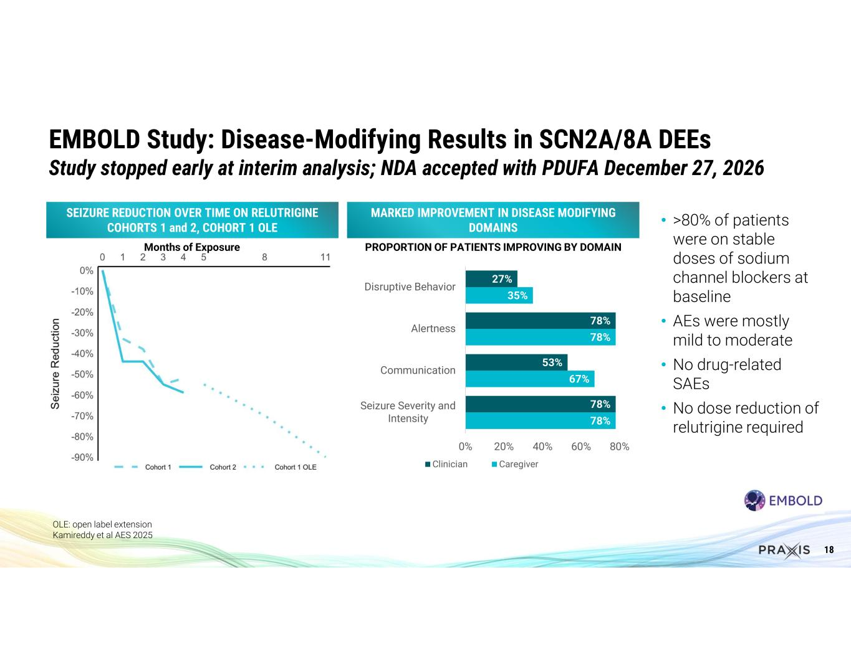
18 OLE: open label extension Kamireddy et al AES 2025 EMBOLD Study: Disease-Modifying Results in SCN2A/8A DEEs Study stopped early at interim analysis; NDA accepted with PDUFA December 27, 2026 • >80% of patients were on stable doses of sodium channel blockers at baseline • AEs were mostly mild to moderate • No drug-related SAEs • No dose reduction of relutrigine required MARKED IMPROVEMENT IN DISEASE MODIFYING DOMAINS 78% 67% 78% 35% 78% 53% 78% 27% 0% 20% 40% 60% 80% Seizure Severity and Intensity Communication Alertness Disruptive Behavior Clinician Caregiver SEIZURE REDUCTION OVER TIME ON RELUTRIGINE COHORTS 1 and 2, COHORT 1 OLE PROPORTION OF PATIENTS IMPROVING BY DOMAINMonths of Exposure

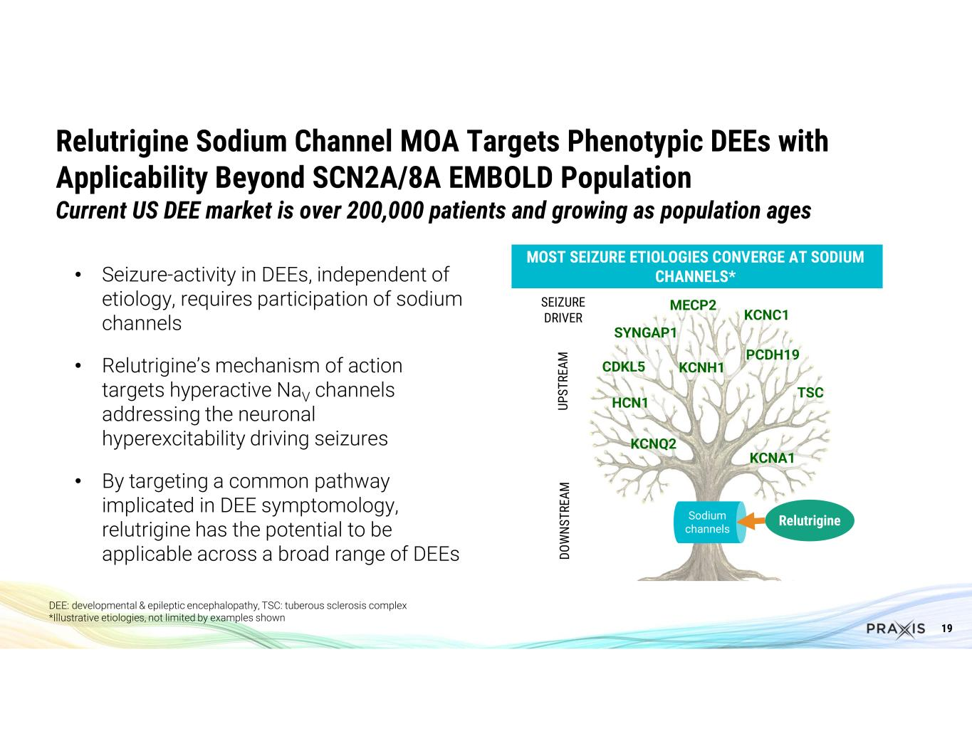
19 • Seizure-activity in DEEs, independent of etiology, requires participation of sodium channels • Relutrigine’s mechanism of action targets hyperactive NaV channels addressing the neuronal hyperexcitability driving seizures • By targeting a common pathway implicated in DEE symptomology, relutrigine has the potential to be applicable across a broad range of DEEs Relutrigine Sodium Channel MOA Targets Phenotypic DEEs with Applicability Beyond SCN2A/8A EMBOLD Population Current US DEE market is over 200,000 patients and growing as population ages DEE: developmental & epileptic encephalopathy, TSC: tuberous sclerosis complex *Illustrative etiologies, not limited by examples shown CDKL5 KCNQ2 TSC MECP2 UP ST RE AM DO W N ST RE AM KCNH1 KCNC1 KCNA1 HCN1 PCDH19 SYNGAP1 SEIZURE DRIVER MOST SEIZURE ETIOLOGIES CONVERGE AT SODIUM CHANNELS* Sodium channels Relutrigine

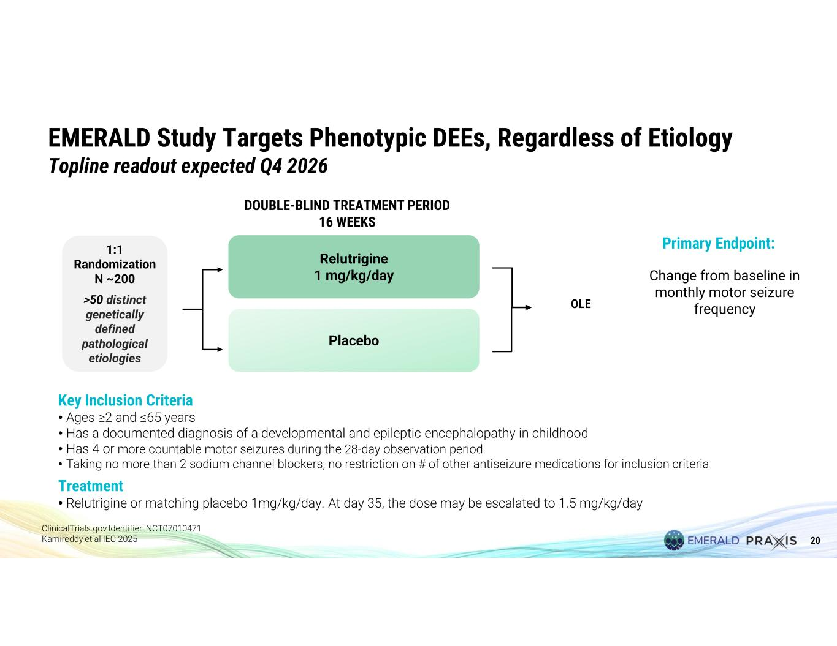
20 EMERALD Study Targets Phenotypic DEEs, Regardless of Etiology Topline readout expected Q4 2026 Key Inclusion Criteria • Ages ≥2 and ≤65 years • Has a documented diagnosis of a developmental and epileptic encephalopathy in childhood • Has 4 or more countable motor seizures during the 28-day observation period • Taking no more than 2 sodium channel blockers; no restriction on # of other antiseizure medications for inclusion criteria Treatment • Relutrigine or matching placebo 1mg/kg/day. At day 35, the dose may be escalated to 1.5 mg/kg/day Relutrigine 1 mg/kg/day 1:1 Randomization N ~200 >50 distinct genetically defined pathological etiologies Placebo OLE DOUBLE-BLIND TREATMENT PERIOD 16 WEEKS Primary Endpoint: Change from baseline in monthly motor seizure frequency ClinicalTrials.gov Identifier: NCT07010471 Kamireddy et al IEC 2025

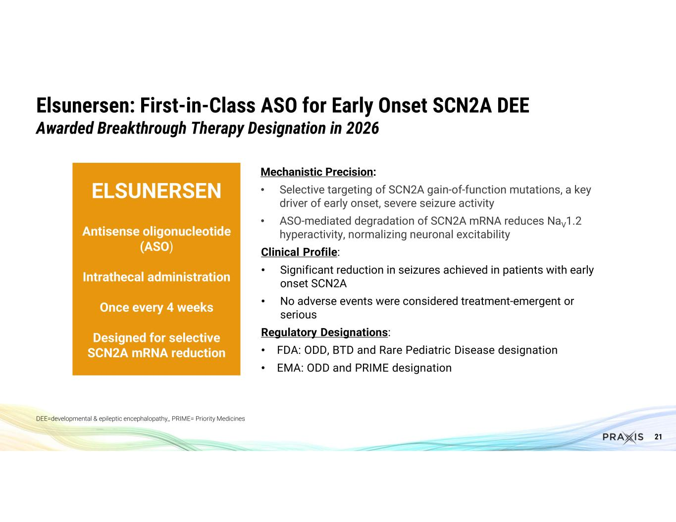
21 Mechanistic Precision: • Selective targeting of SCN2A gain-of-function mutations, a key driver of early onset, severe seizure activity • ASO-mediated degradation of SCN2A mRNA reduces NaV1.2 hyperactivity, normalizing neuronal excitability Clinical Profile: • Significant reduction in seizures achieved in patients with early onset SCN2A • No adverse events were considered treatment-emergent or serious Regulatory Designations: • FDA: ODD, BTD and Rare Pediatric Disease designation • EMA: ODD and PRIME designation Elsunersen: First-in-Class ASO for Early Onset SCN2A DEE Awarded Breakthrough Therapy Designation in 2026 ELSUNERSEN Antisense oligonucleotide (ASO) Intrathecal administration Once every 4 weeks Designed for selective SCN2A mRNA reduction DEE=developmental & epileptic encephalopathy,, PRIME= Priority Medicines

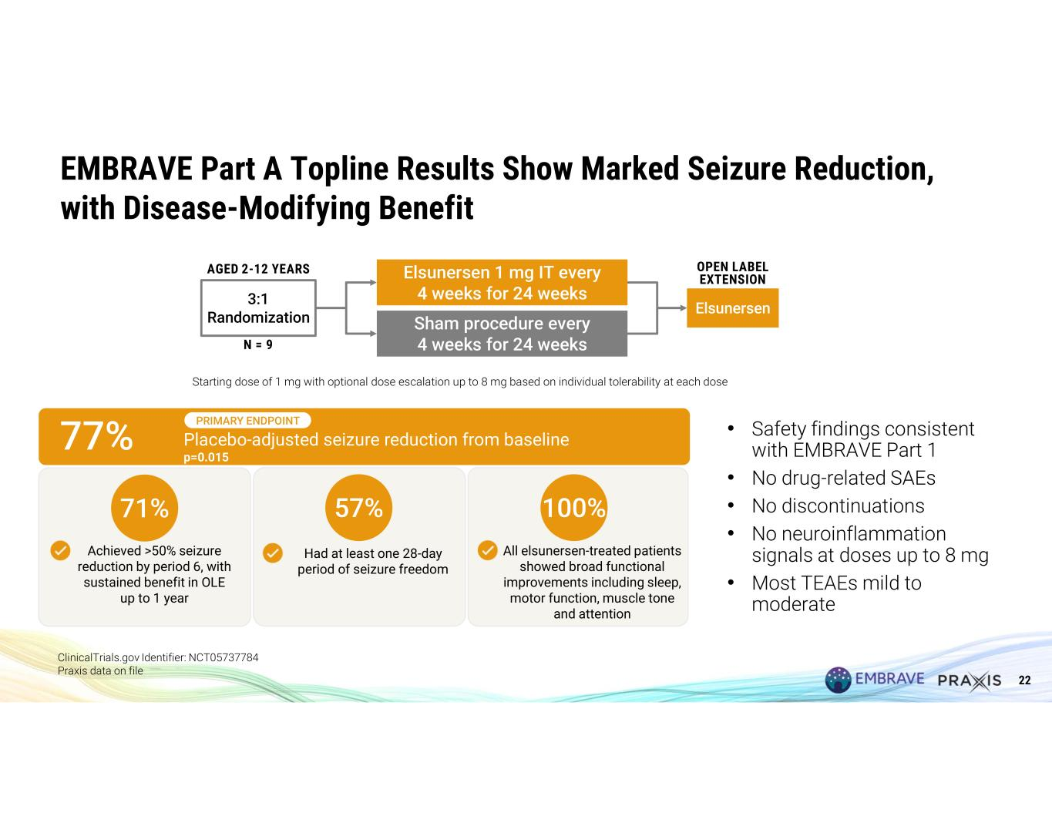
22 EMBRAVE Part A Topline Results Show Marked Seizure Reduction, with Disease-Modifying Benefit ClinicalTrials.gov Identifier: NCT05737784 Praxis data on file Elsunersen 3:1 Randomization OPEN LABEL EXTENSIONElsunersen 1 mg IT every 4 weeks for 24 weeks Sham procedure every 4 weeks for 24 weeks AGED 2-12 YEARS N = 9 Starting dose of 1 mg with optional dose escalation up to 8 mg based on individual tolerability at each dose 77% Placebo-adjusted seizure reduction from baseline p=0.015 PRIMARY ENDPOINT All elsunersen-treated patients showed broad functional improvements including sleep, motor function, muscle tone and attention Achieved >50% seizure reduction by period 6, with sustained benefit in OLE up to 1 year Had at least one 28-day period of seizure freedom 71% 57% 100% • Safety findings consistent with EMBRAVE Part 1 • No drug-related SAEs • No discontinuations • No neuroinflammation signals at doses up to 8 mg • Most TEAEs mild to moderate

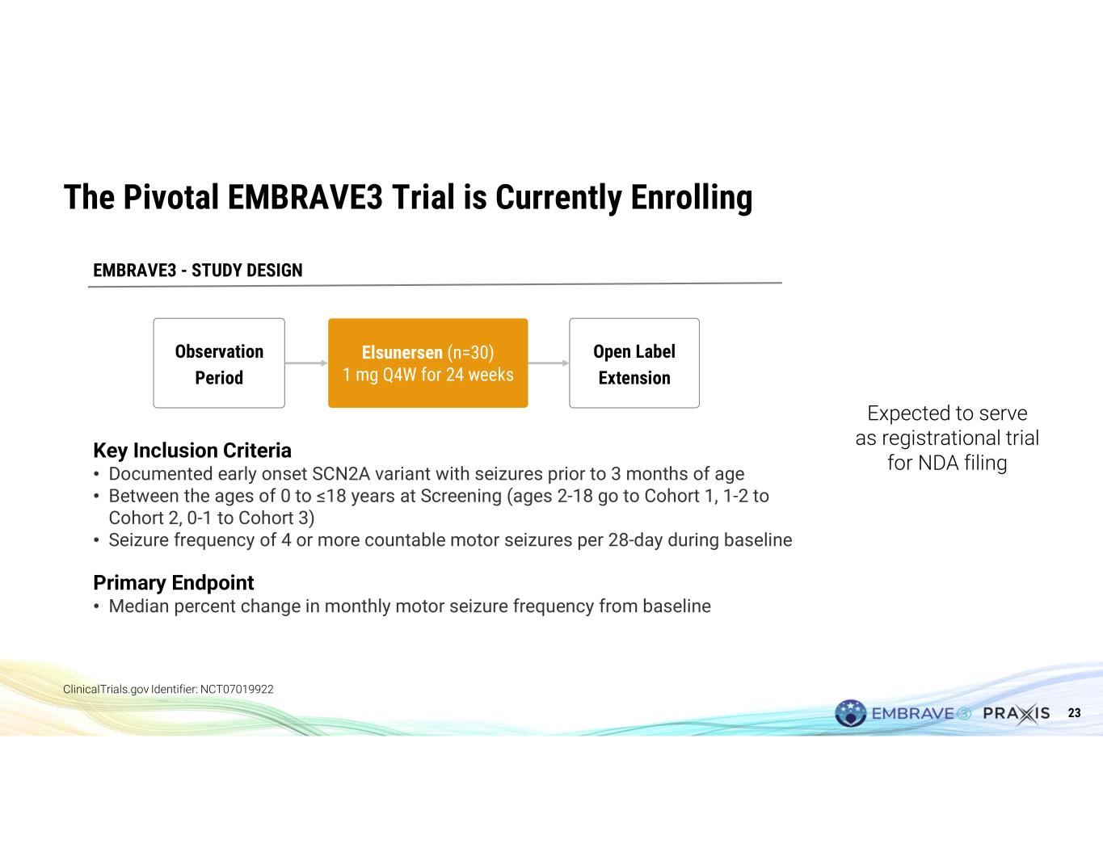
23 The Pivotal EMBRAVE3 Trial is Currently Enrolling ClinicalTrials.gov Identifier: NCT07019922 EMBRAVE3 - STUDY DESIGN Key Inclusion Criteria • Documented early onset SCN2A variant with seizures prior to 3 months of age • Between the ages of 0 to ≤18 years at Screening (ages 2-18 go to Cohort 1, 1-2 to Cohort 2, 0-1 to Cohort 3) • Seizure frequency of 4 or more countable motor seizures per 28-day during baseline Primary Endpoint • Median percent change in monthly motor seizure frequency from baseline Elsunersen (n=30) 1 mg Q4W for 24 weeks Open Label Extension Observation Period Expected to serve as registrational trial for NDA filing

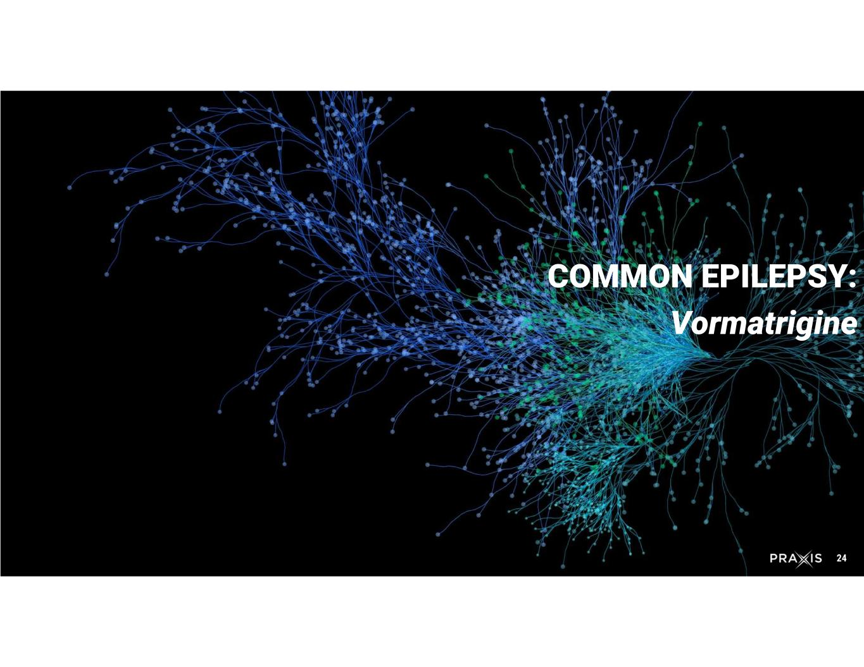
24 COMMON EPILEPSY: Vormatrigine

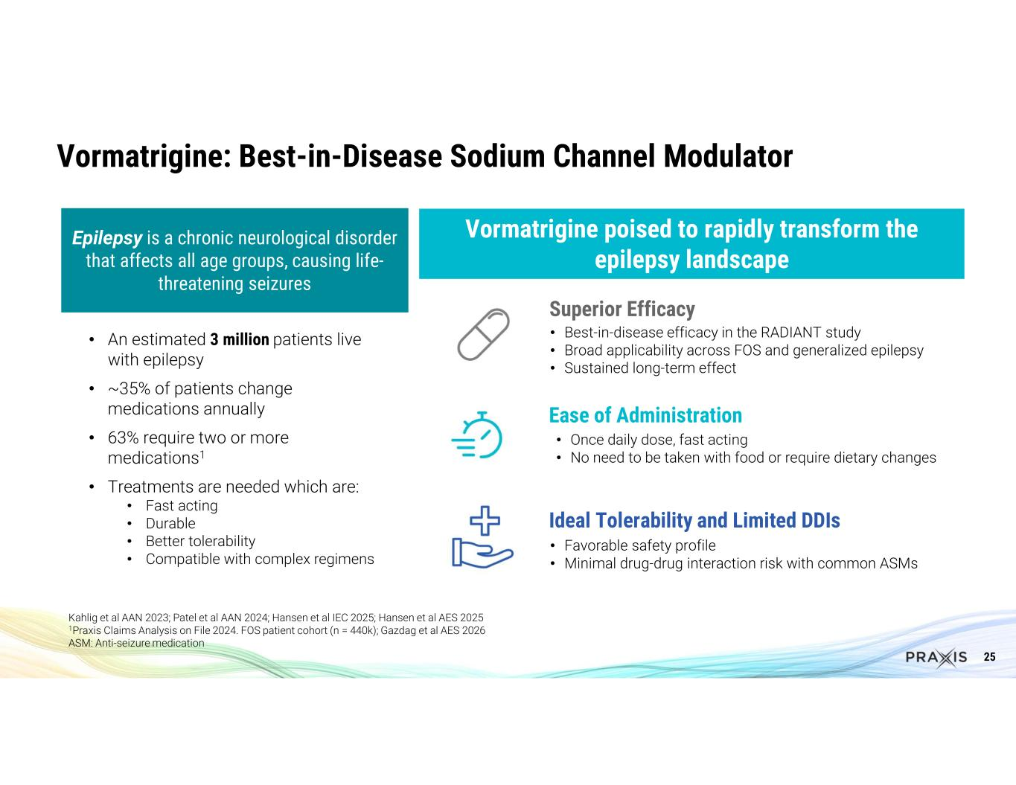
25 Kahlig et al AAN 2023; Patel et al AAN 2024; Hansen et al IEC 2025; Hansen et al AES 2025 1Praxis Claims Analysis on File 2024. FOS patient cohort (n = 440k); Gazdag et al AES 2026 ASM: Anti-seizure medication • An estimated 3 million patients live with epilepsy • ~35% of patients change medications annually • 63% require two or more medications1 • Treatments are needed which are: • Fast acting • Durable • Better tolerability • Compatible with complex regimens Vormatrigine poised to rapidly transform the epilepsy landscape • Once daily dose, fast acting • No need to be taken with food or require dietary changes Ease of Administration • Favorable safety profile • Minimal drug-drug interaction risk with common ASMs Ideal Tolerability and Limited DDIs Vormatrigine: Best-in-Disease Sodium Channel Modulator • Best-in-disease efficacy in the RADIANT study • Broad applicability across FOS and generalized epilepsy • Sustained long-term effect Superior Efficacy Epilepsy is a chronic neurological disorder that affects all age groups, causing life- threatening seizures

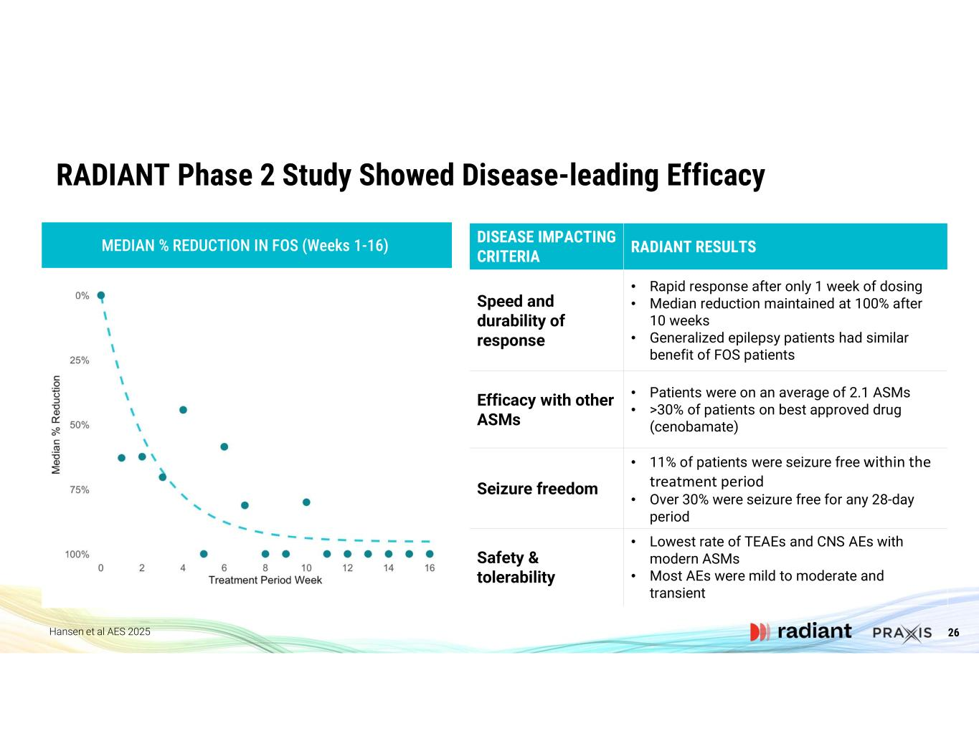
26 MEDIAN % REDUCTION IN FOS (Weeks 1-16) RADIANT Phase 2 Study Showed Disease-leading Efficacy Hansen et al AES 2025 RADIANT RESULTS DISEASE IMPACTING CRITERIA • Rapid response after only 1 week of dosing • Median reduction maintained at 100% after 10 weeks • Generalized epilepsy patients had similar benefit of FOS patients Speed and durability of response • Patients were on an average of 2.1 ASMs • >30% of patients on best approved drug (cenobamate) Efficacy with other ASMs • 11% of patients were seizure free within the treatment period • Over 30% were seizure free for any 28-day period Seizure freedom • Lowest rate of TEAEs and CNS AEs with modern ASMs • Most AEs were mild to moderate and transient Safety & tolerability

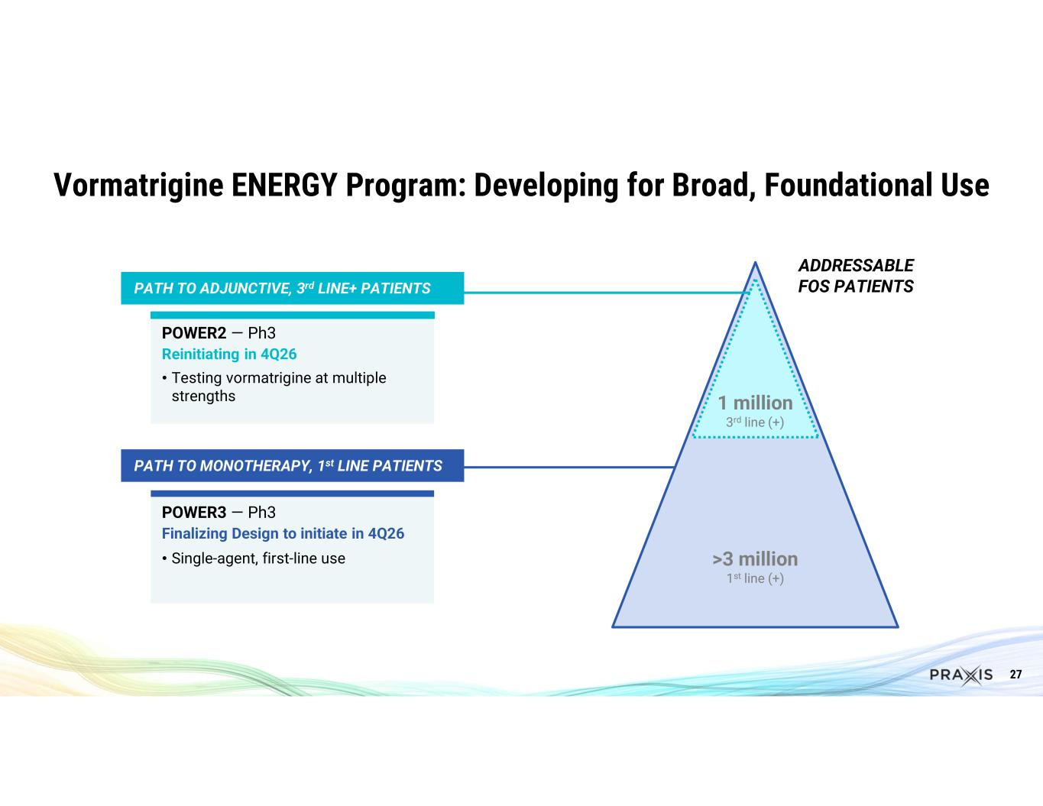
27 Vormatrigine ENERGY Program: Developing for Broad, Foundational Use POWER2 — Ph3 Reinitiating in 4Q26 • Testing vormatrigine at multiple strengths POWER3 — Ph3 Finalizing Design to initiate in 4Q26 • Single-agent, first-line use ADDRESSABLE FOS PATIENTSPATH TO ADJUNCTIVE, 3rd LINE+ PATIENTS PATH TO MONOTHERAPY, 1st LINE PATIENTS 1 million 3rd line (+) >3 million 1st line (+)

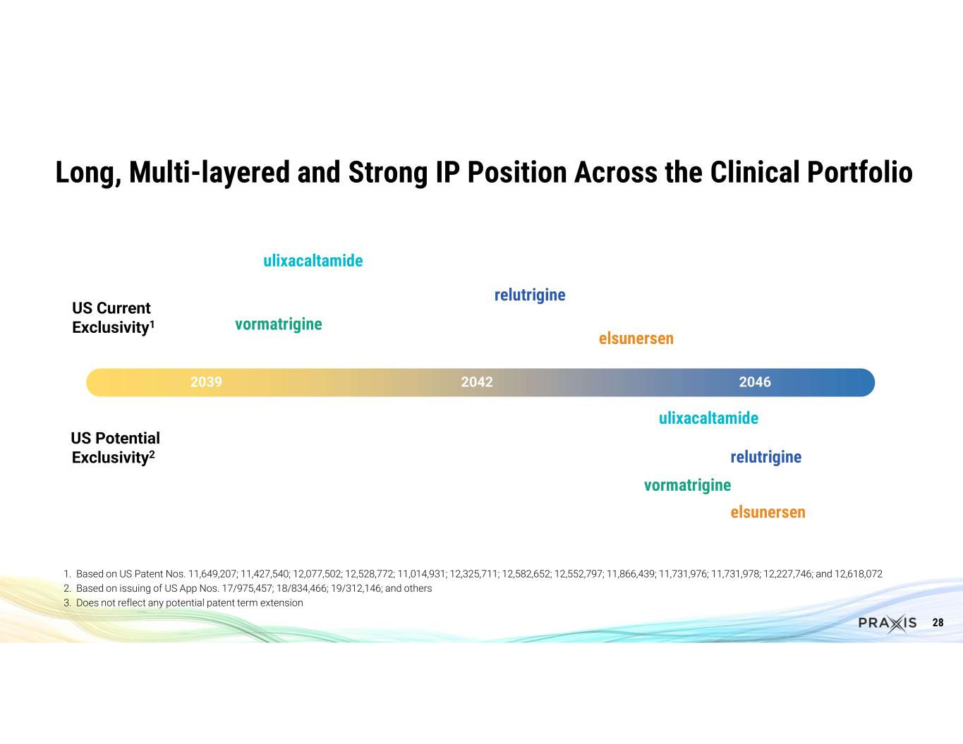
28 Long, Multi-layered and Strong IP Position Across the Clinical Portfolio 2039 2042 2046 relutrigine ulixacaltamide vormatrigine US Current Exclusivity1 US Potential Exclusivity2 ulixacaltamide relutrigine vormatrigine elsunersen elsunersen 1. Based on US Patent Nos. 11,649,207; 11,427,540; 12,077,502; 12,528,772; 11,014,931; 12,325,711; 12,582,652; 12,552,797; 11,866,439; 11,731,976; 11,731,978; 12,227,746; and 12,618,072 2. Based on issuing of US App Nos. 17/975,457; 18/834,466; 19/312,146; and others 3. Does not reflect any potential patent term extension


29 Two Platforms Enabling Repeatable CNS Innovation 1 Ulixacaltamide has received Breakthrough Therapy Designation (BTD) 2 Relutrigine has received BTD, Orphan Drug Designation (ODD) and Rare Pediatric Disease (RPD) designation from the FDA, and ODD from the European Medicines Agency (EMA) for the treatment of SCN2A and SCN8A-DEE and RPD designation for Dravet Syndrome 3 Elsunersen has received BTD, ODD and RPD designation from the FDA, and ODD and Priority Medicines (PRIME) designations from the EMA for the treatment of early SCN2A DEE Note: DEE: developmental & epileptic encephalopathy, FOS: focal onset seizures Cerebrum SMALL MOLECULE PLATFORM Cerebrum utilizes deep understanding of neuronal excitability and neuronal networks and applies a series of computational and experimental tools to develop orally available precision therapies Solidus ANTISENSE OLIGONUCLEOTIDE (ASO) PLATFORM Solidus is an efficient, targeted precision medicine discovery and development engine for ASOs anchored on proprietary, computational methodology MECHANISMINDICATIONMOLECULE Selective T-type calcium channel modulator Essential Tremor1ulixacaltamide Sodium channel functional state modulator for broad use FOS & Generalized Epilepsy vormatrigine Sodium channel functional state modulator for phenotypic DEEs Broad DEEsrelutrigine2 KCNT1 specific inhibitorKCNT1PRAX-020 Not disclosedMovement Disorders PRAX-050 MECHANISMINDICATIONMOLECULE Gapmer ASOEarly onset SCN2Aelsunersen3 Gapmer ASOPCDH19PRAX-080 Splice switching ASOSYNGAP1PRAX-090 Undisclosed mechanism ASOSCN2A AutismPRAX-100


®

